

NAME: NUR QISTINA LIYANA BINTI ZULKERNAINI (276995).

ASSIGNMENT 3 A202 - STIA1123 (GROUP C) PROGRAMMING 2.

OUTPUT GUI :

1. **Software Training (Intelleq QS).**

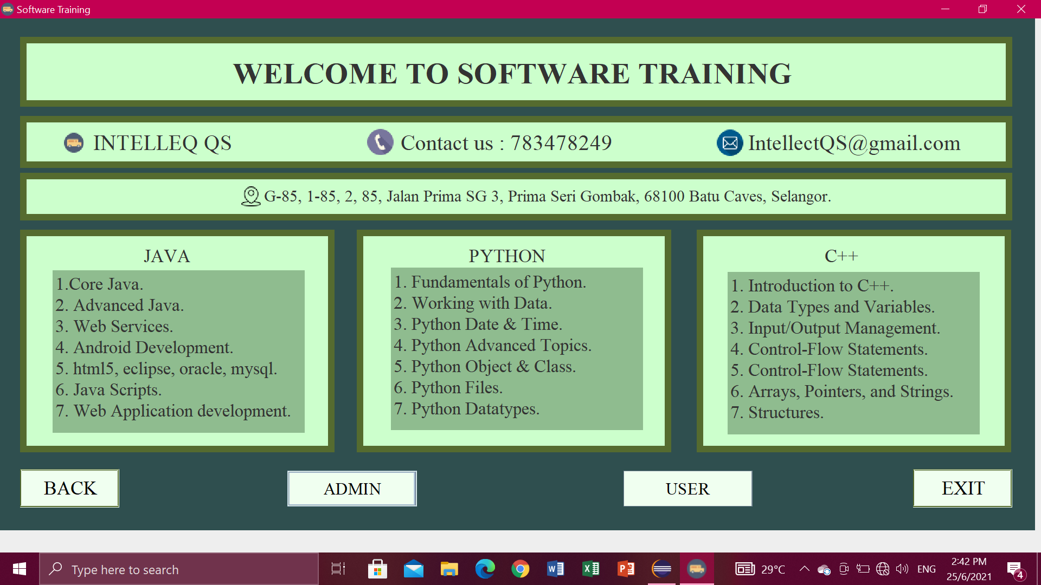

Exit button

* If you are click exit button, it will pop-pup” Confirm if you want to exit”. Then just click Yes or No.

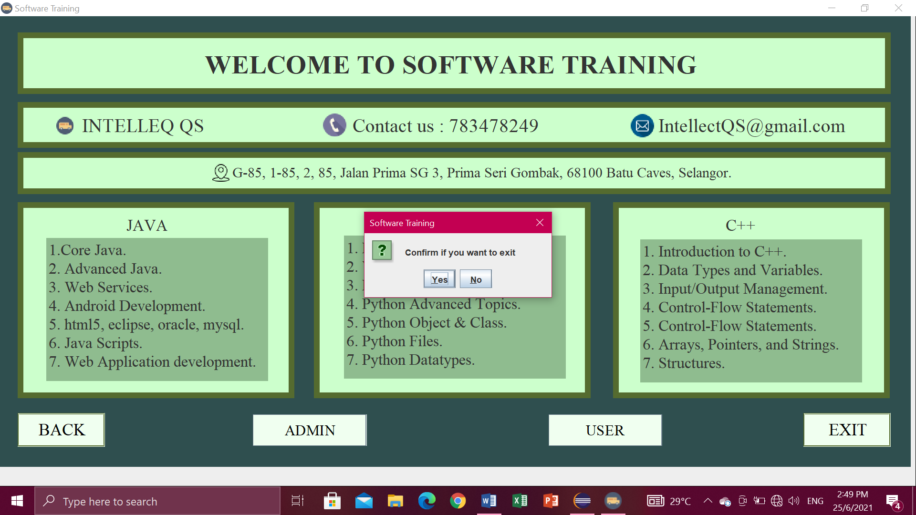

Admin or Users button

- Click Admin or user button, if you click the admin button will go to the login, employee, finance, sales and ads pages.

- If you click the user it will go to the customer page and ads.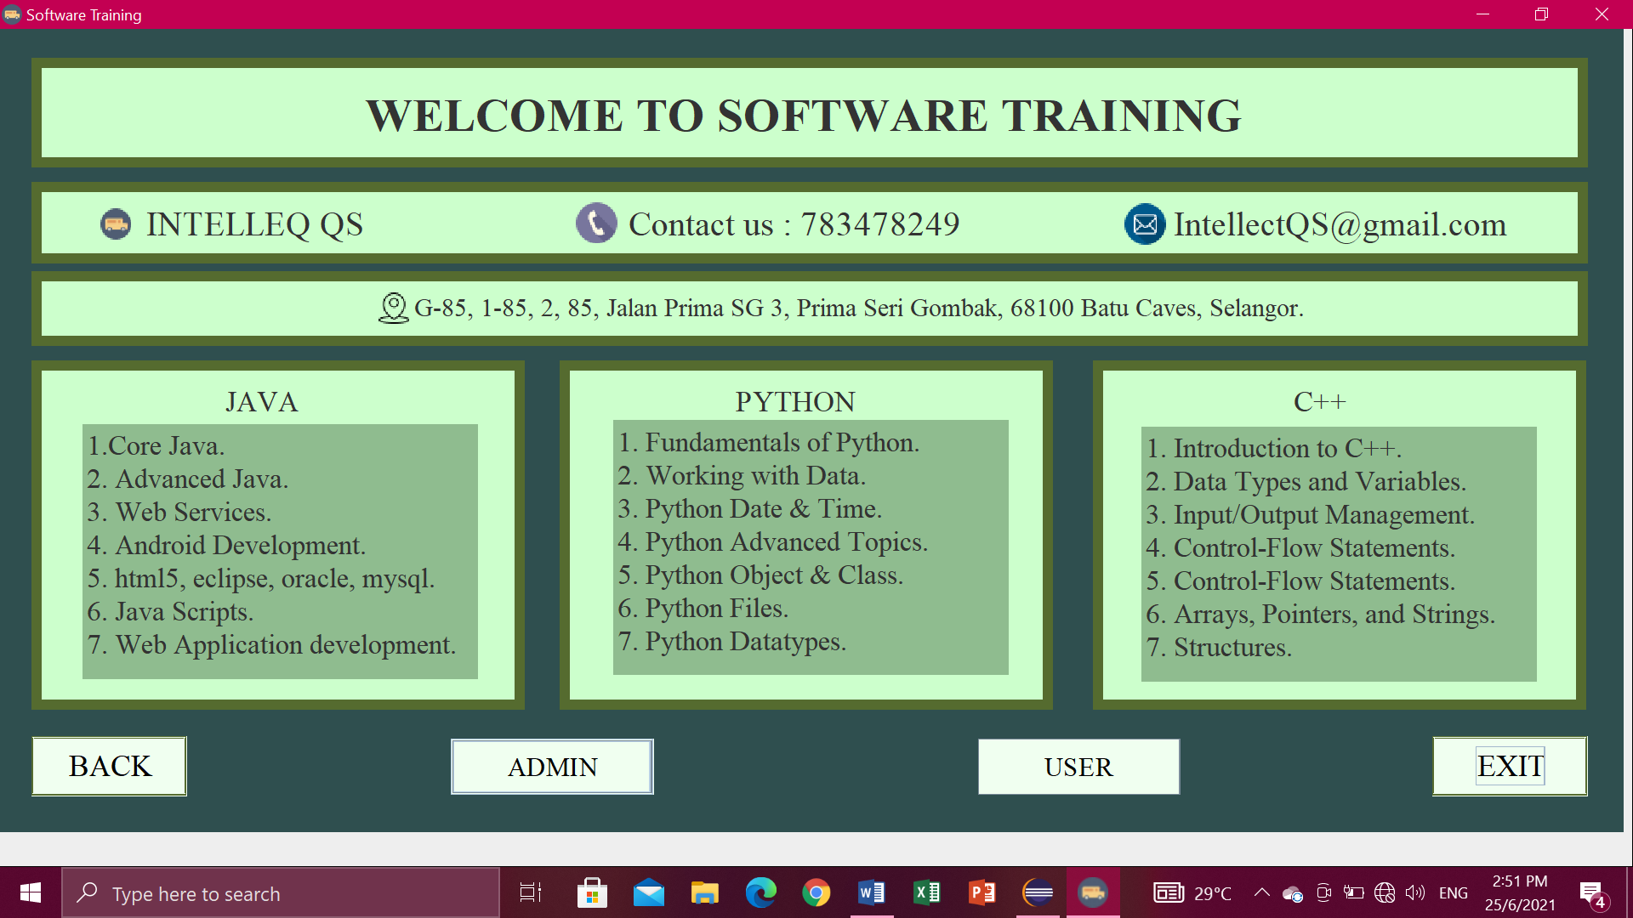

1. **(ADMIN BUTTON) - Login.**

* First Enter the User ID in Text field and Enter Password. Then click button LOGIN.

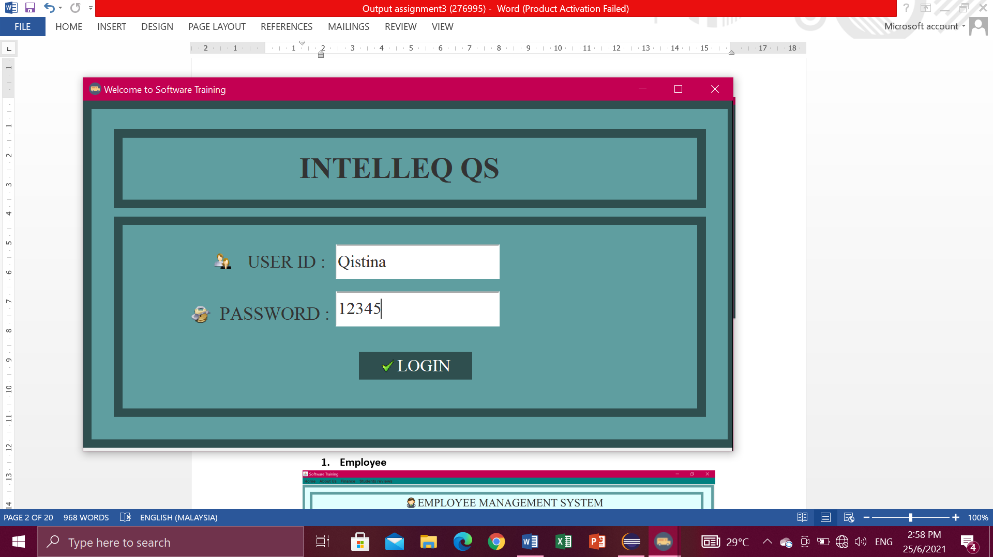

* Then, will pop-up “Login Successful”.

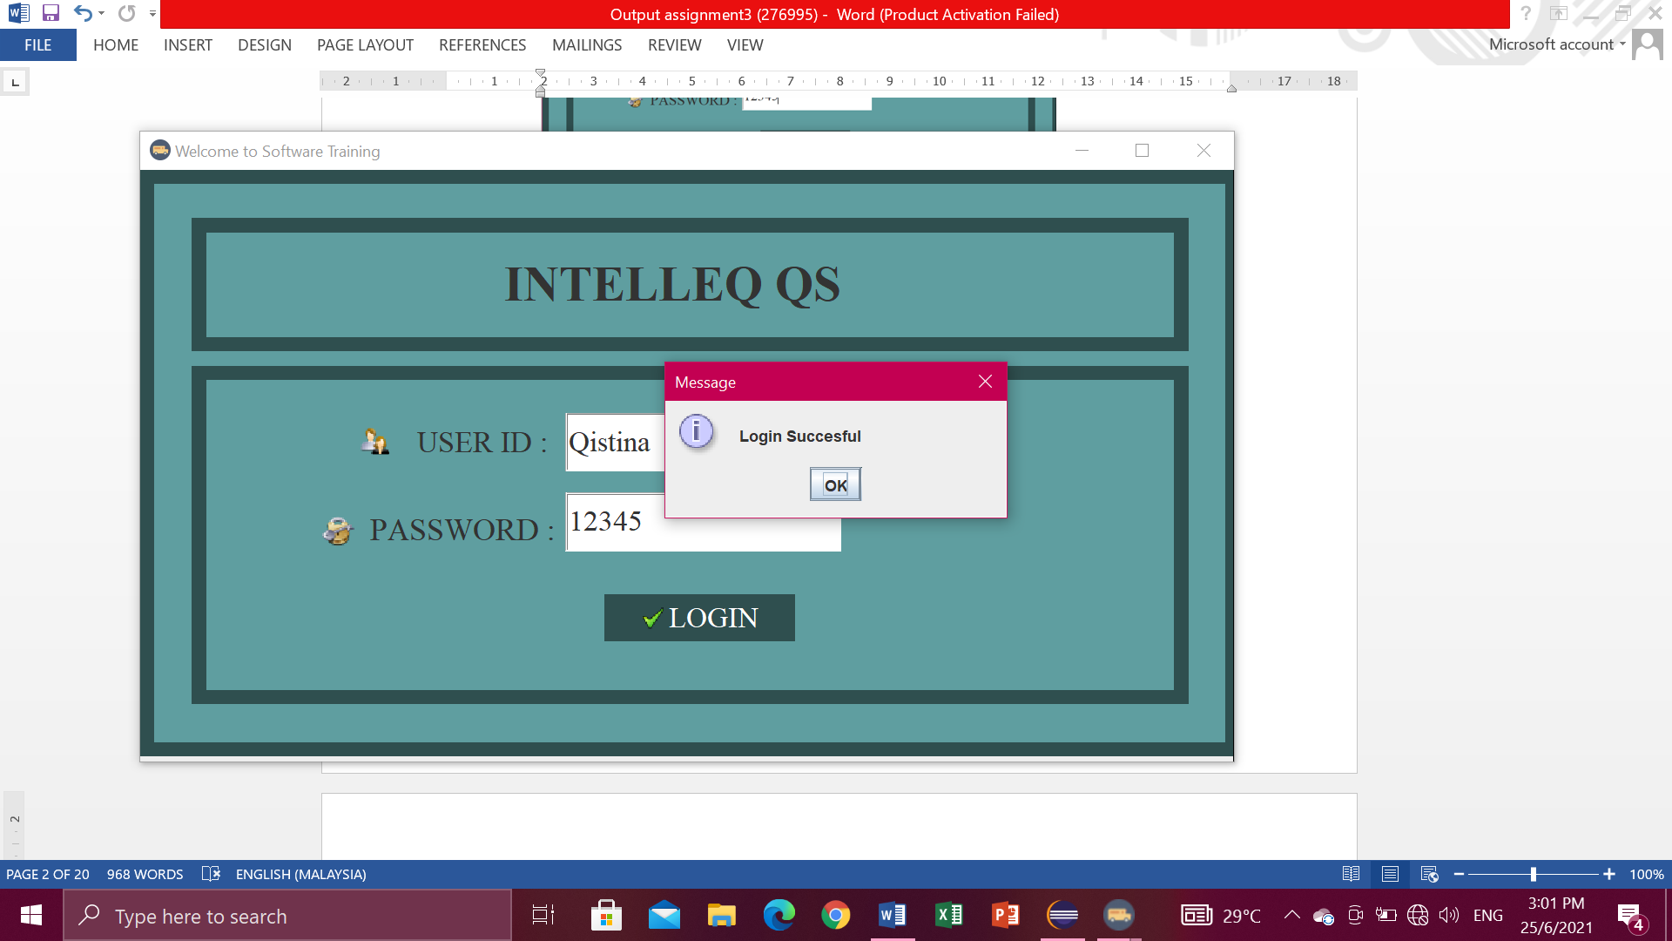

* If you enter the wrong User ID and password. Then it will pop-up "Please enter the right user id and password". 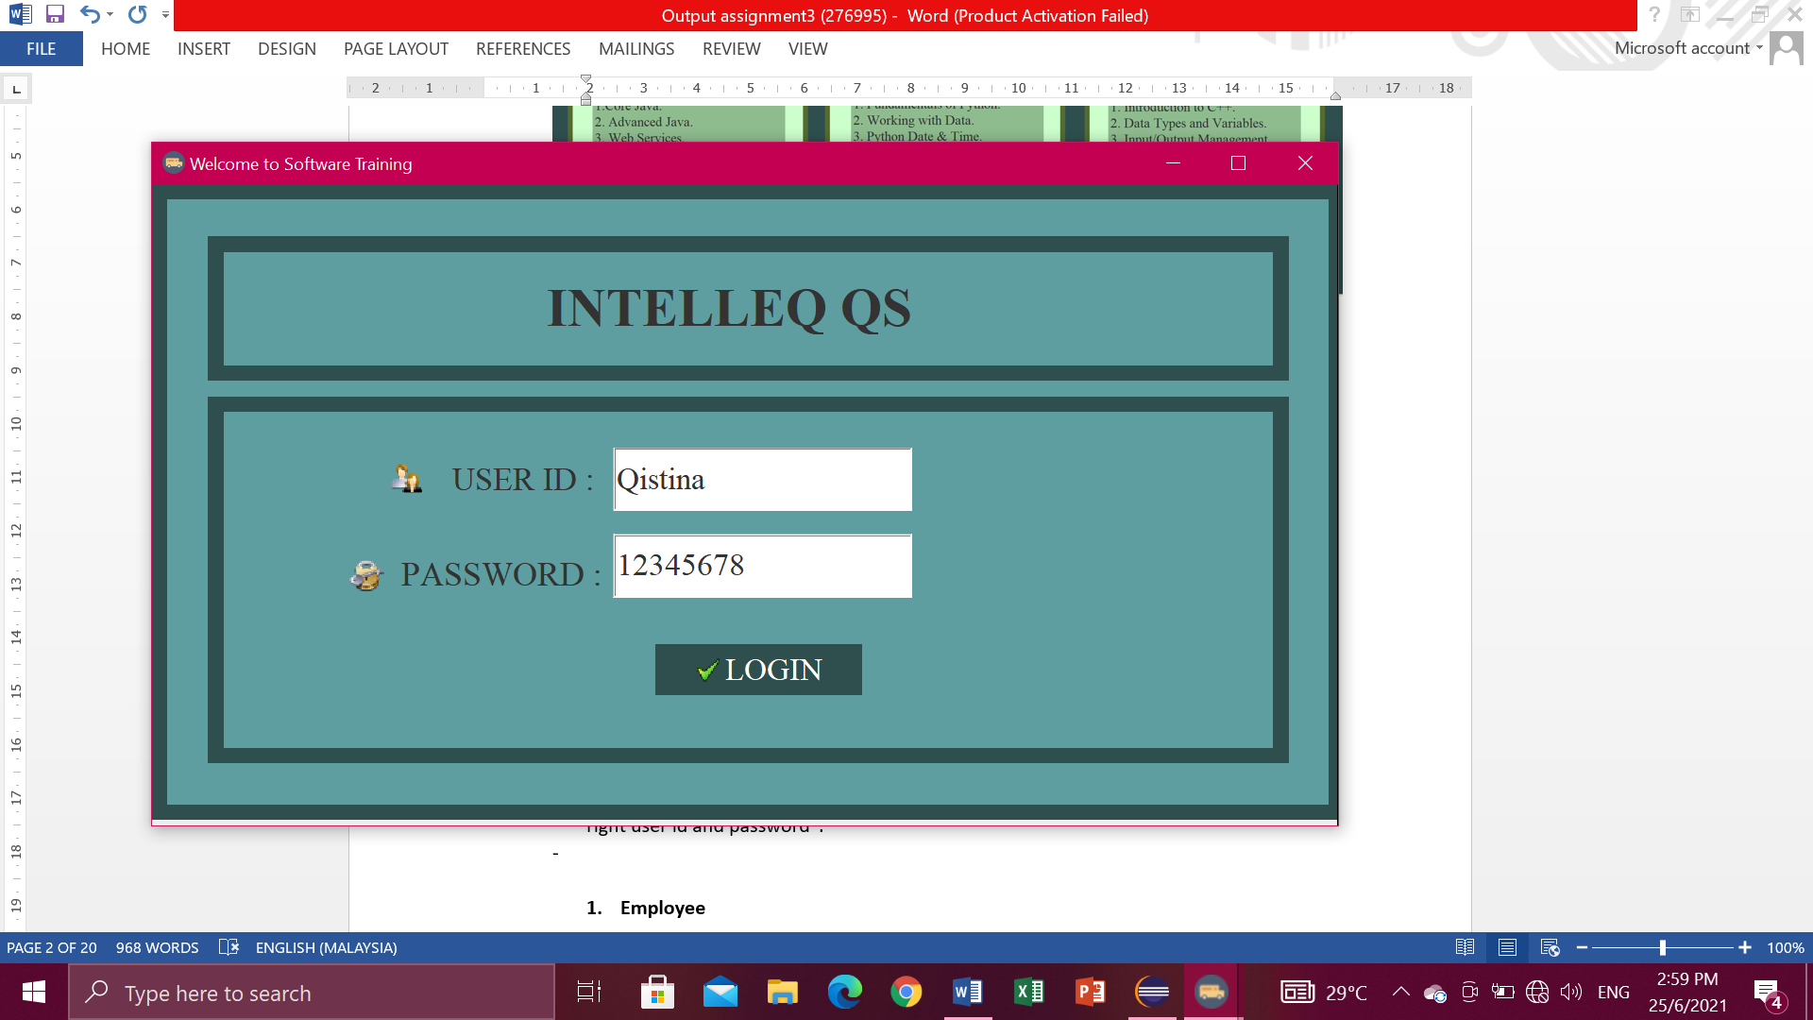

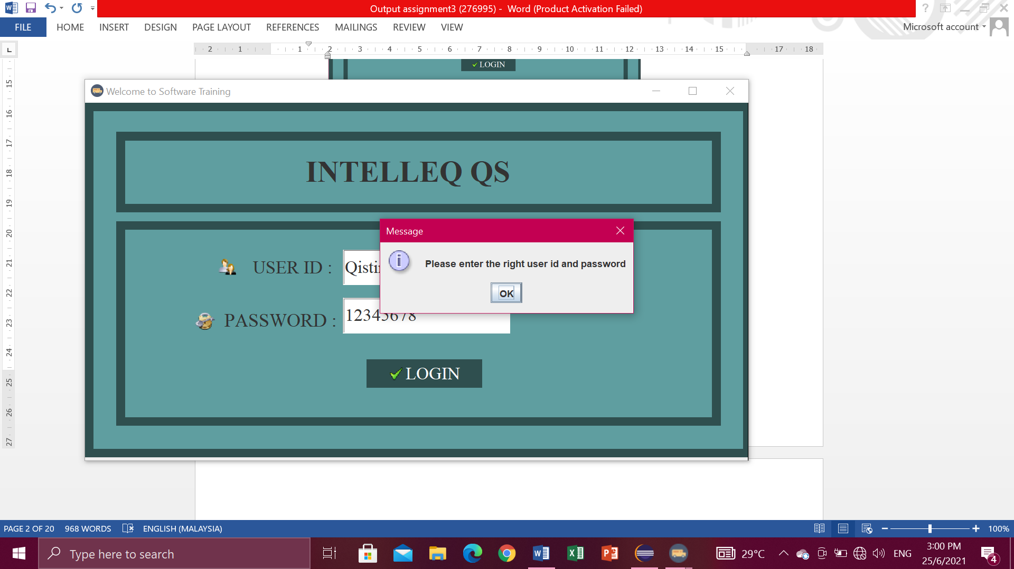

**Employee**

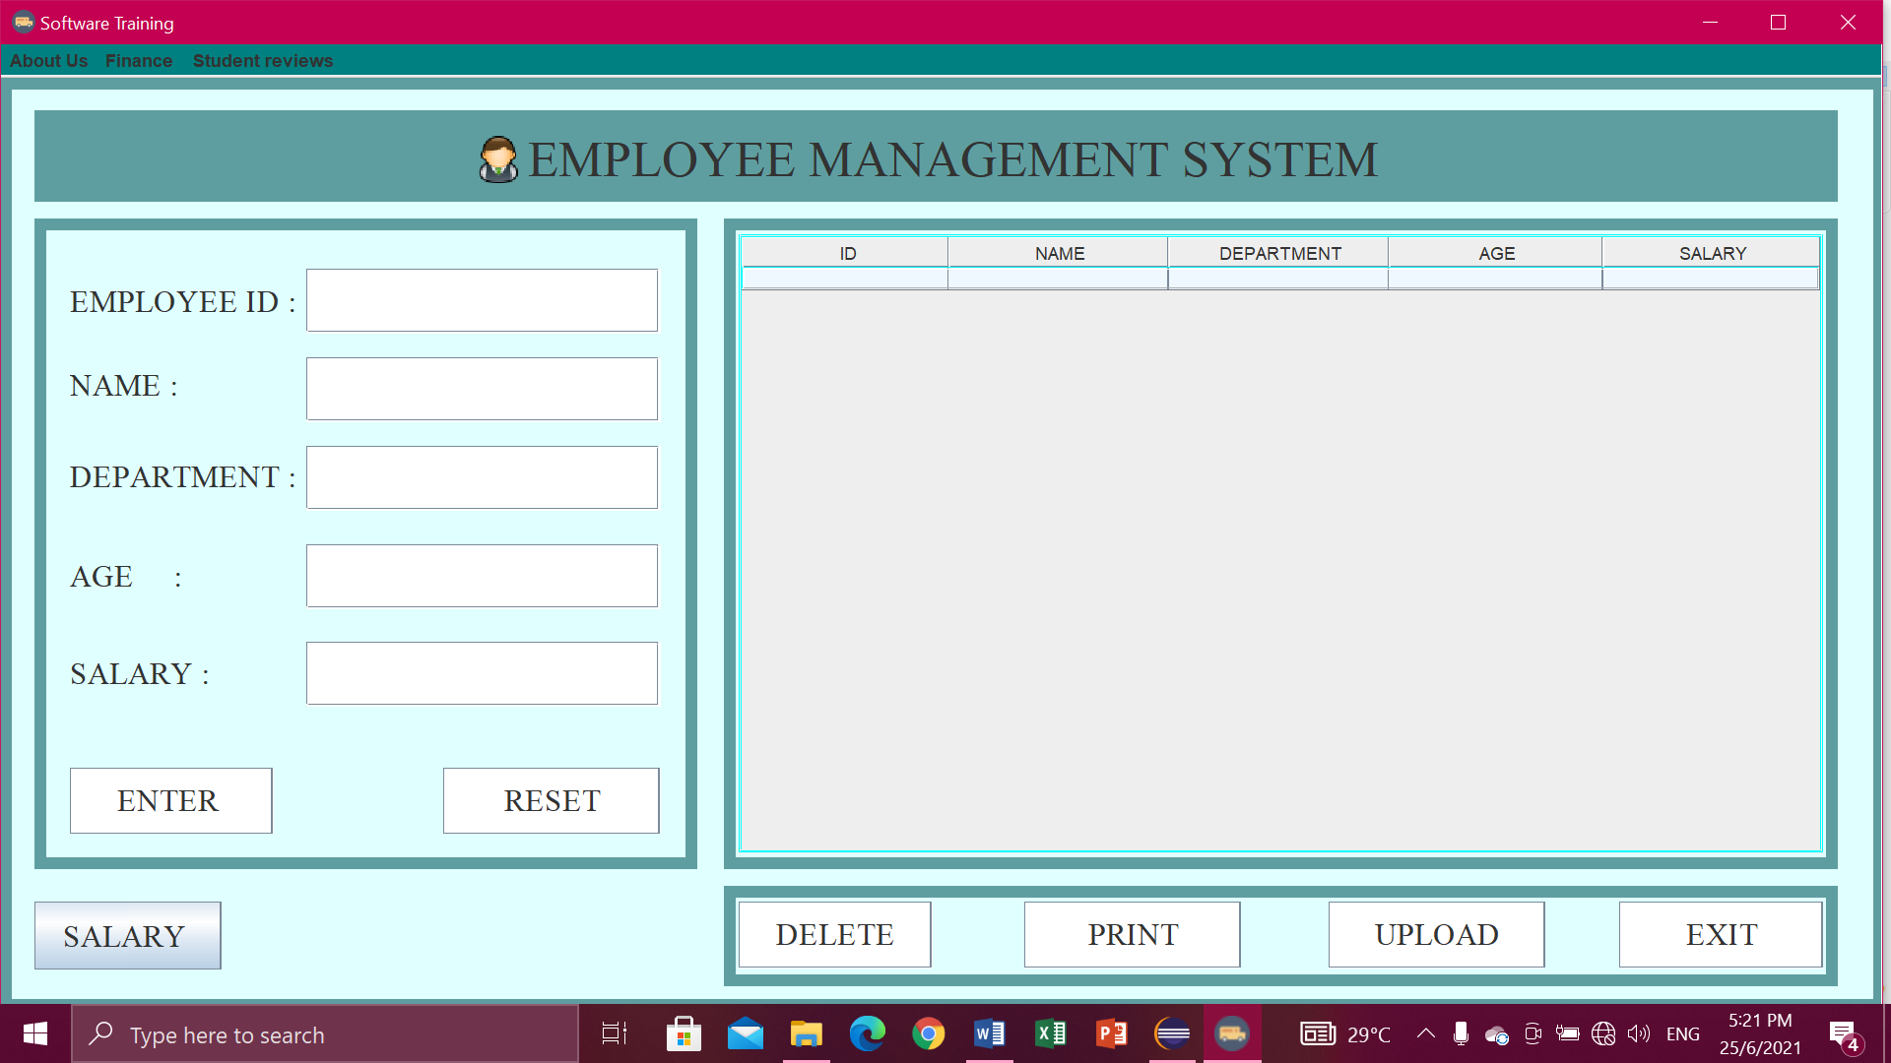

Enter button

* First enter the employee id, name, department, age, and salary in the Text field. Then click the ENTER button. Entered information will appear in the table.

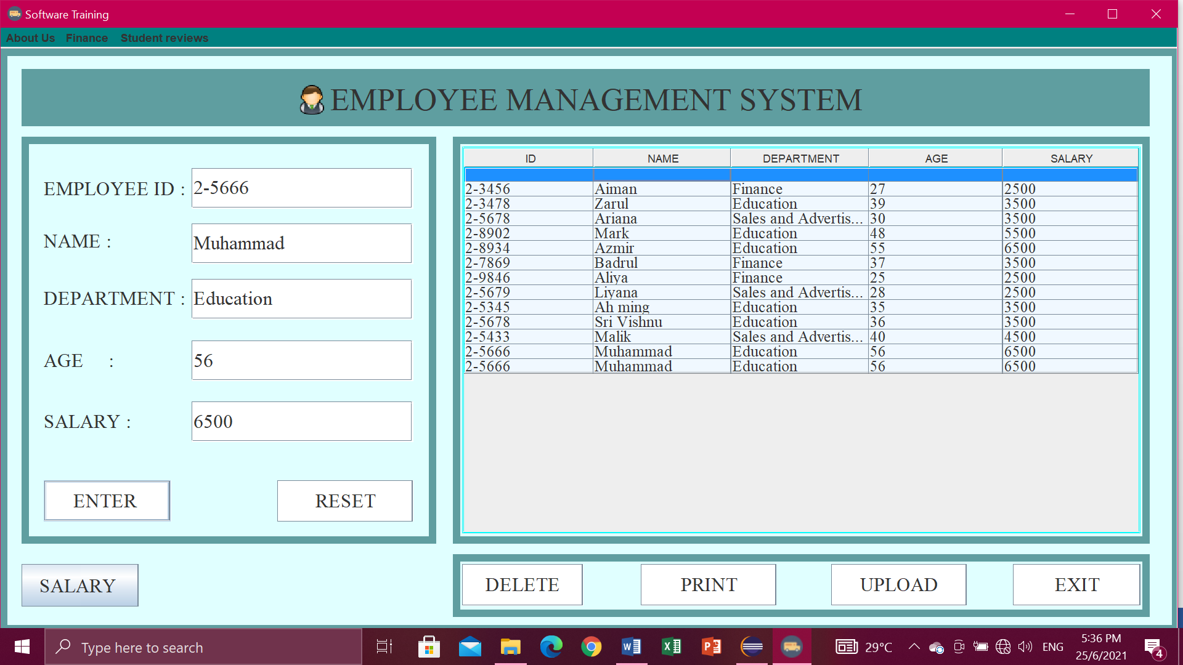

Reset button

* Click button RESET when don’t write data or key in data. So you don’t have to clean one by one.

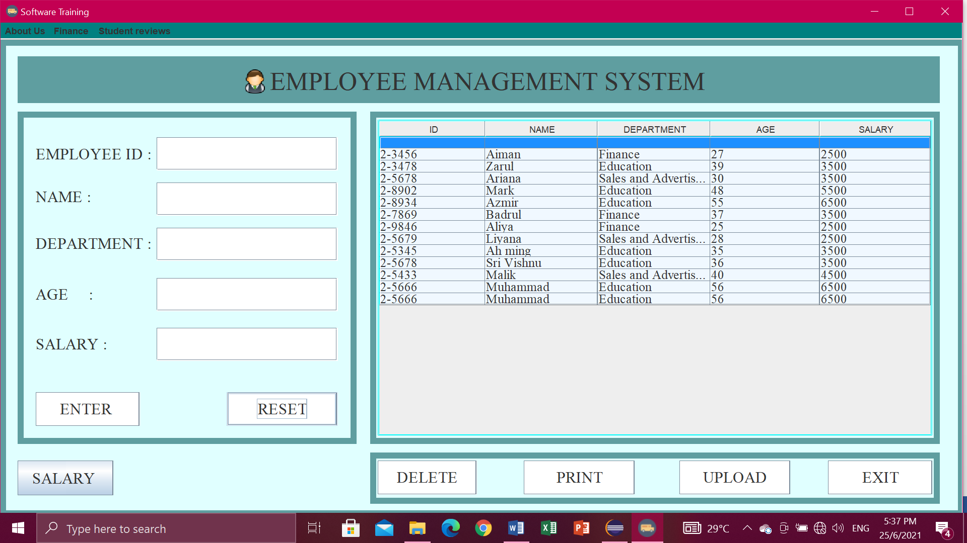

Delete Button

* First you have to select row at table which one want to delete then click button DELETE, if you don’t click row to delete it will pop-up “Select a row to delete” then click OK.

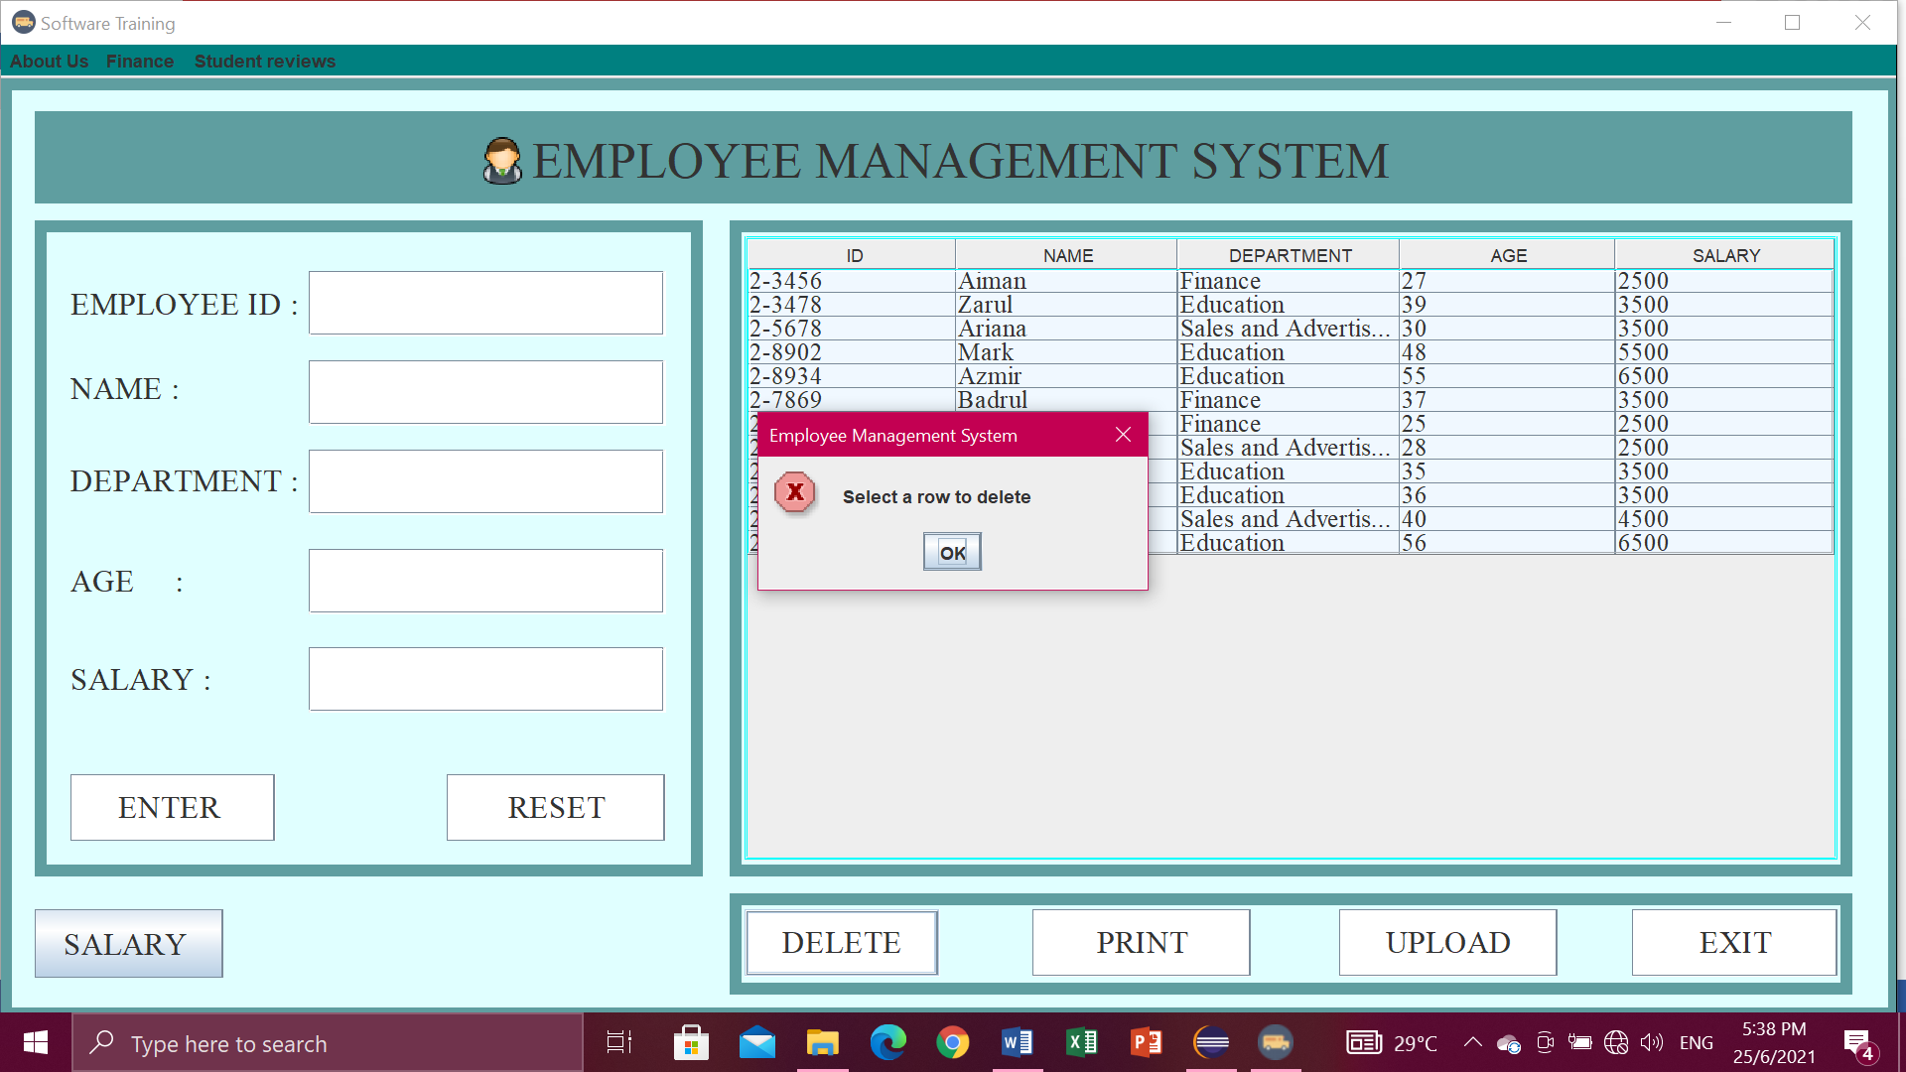

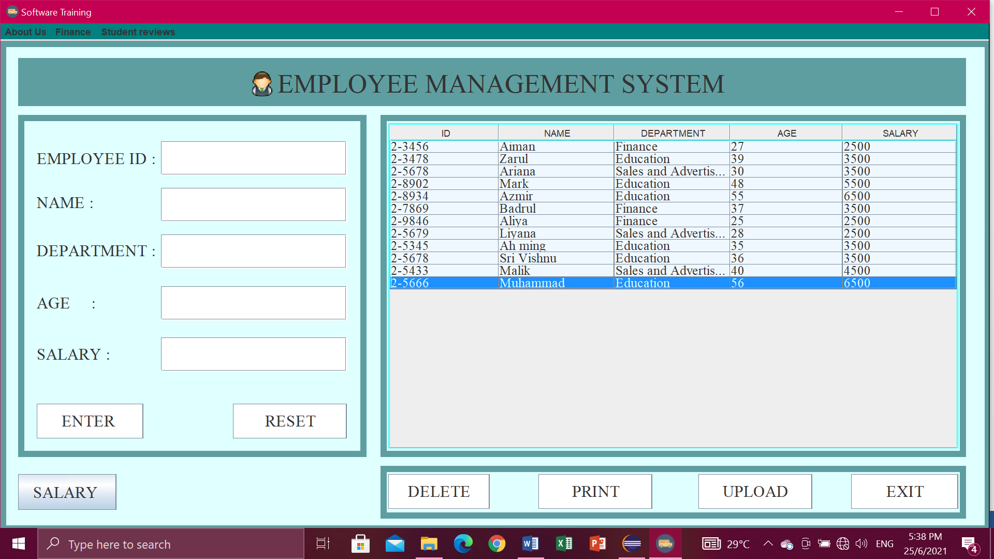

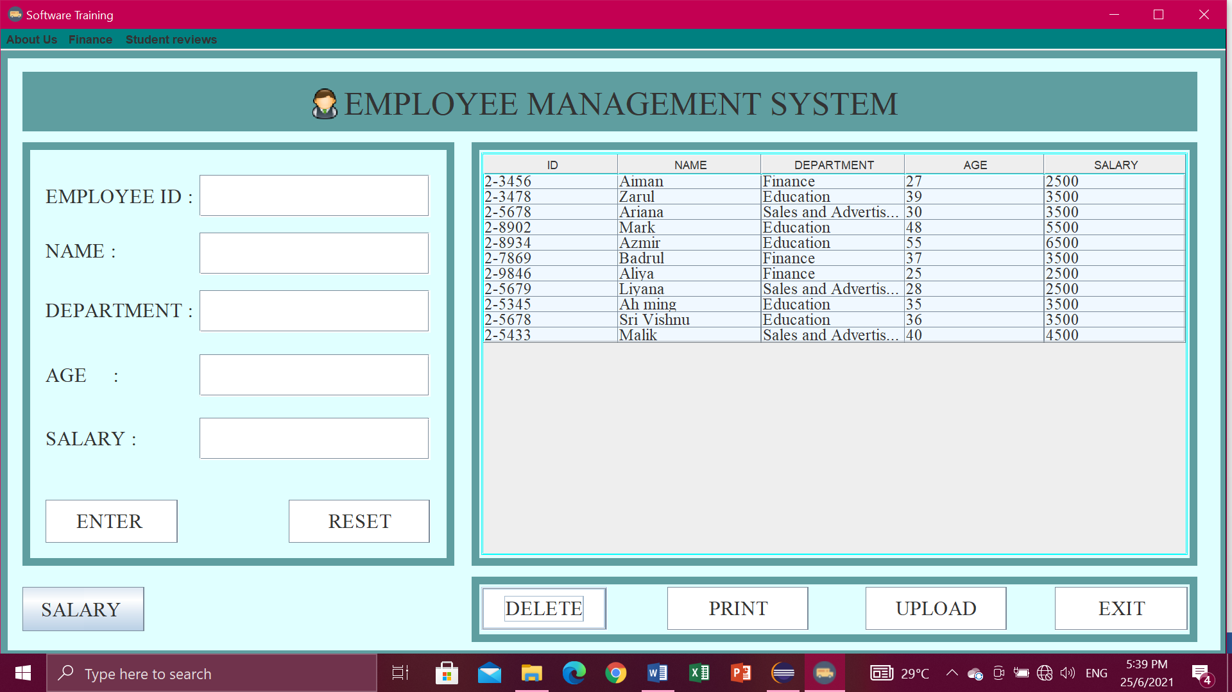

Upload button

* Click button UPLOAD. Then will pop-up “Data Exported”.

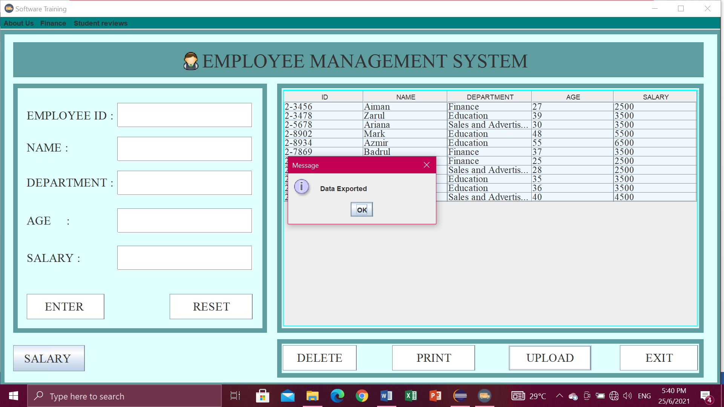

* Data exported into the file io.

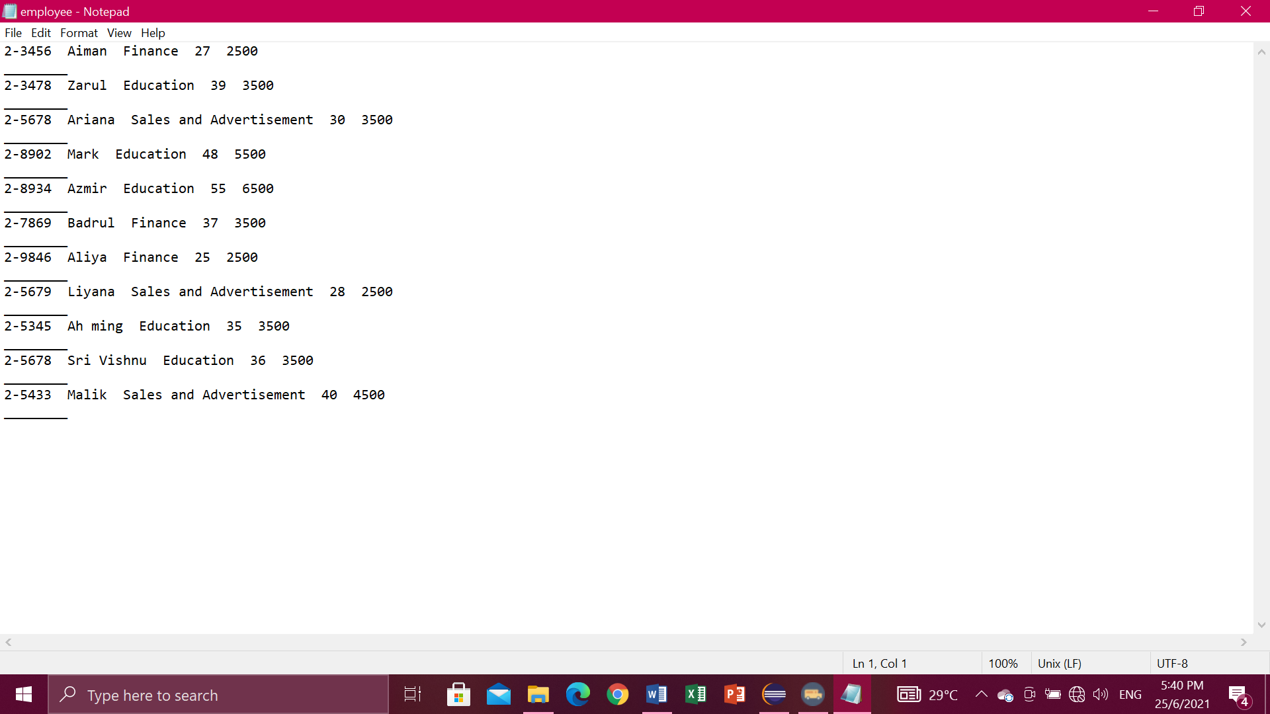

Print button

* Need to "Please select a row first!”.

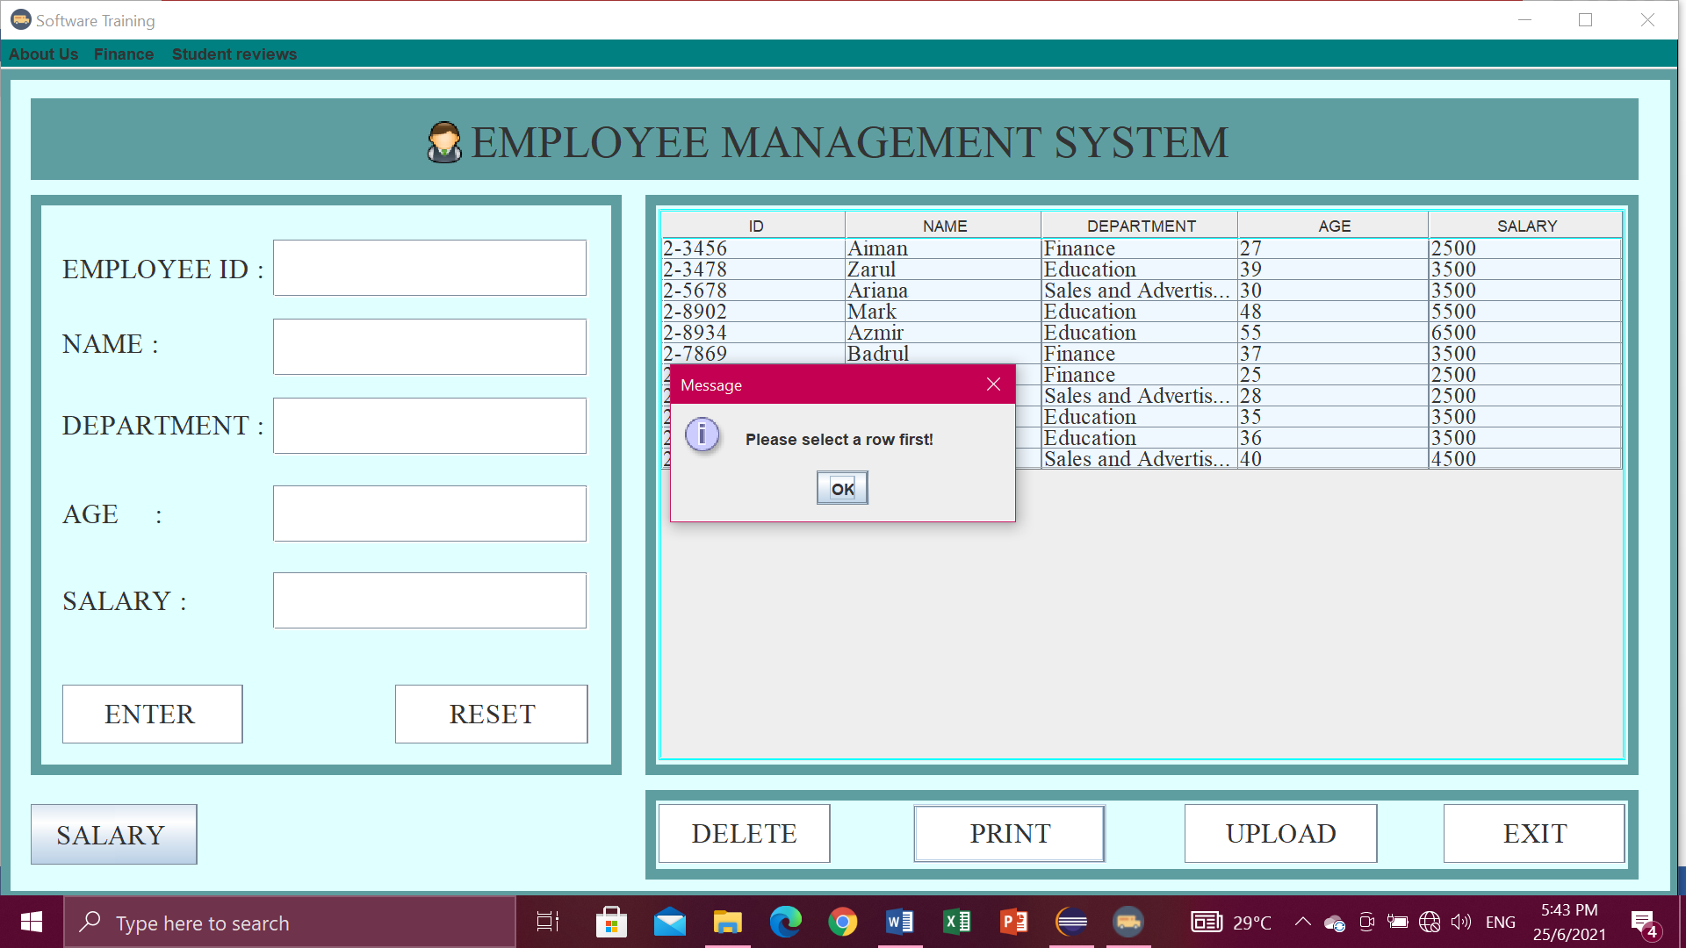

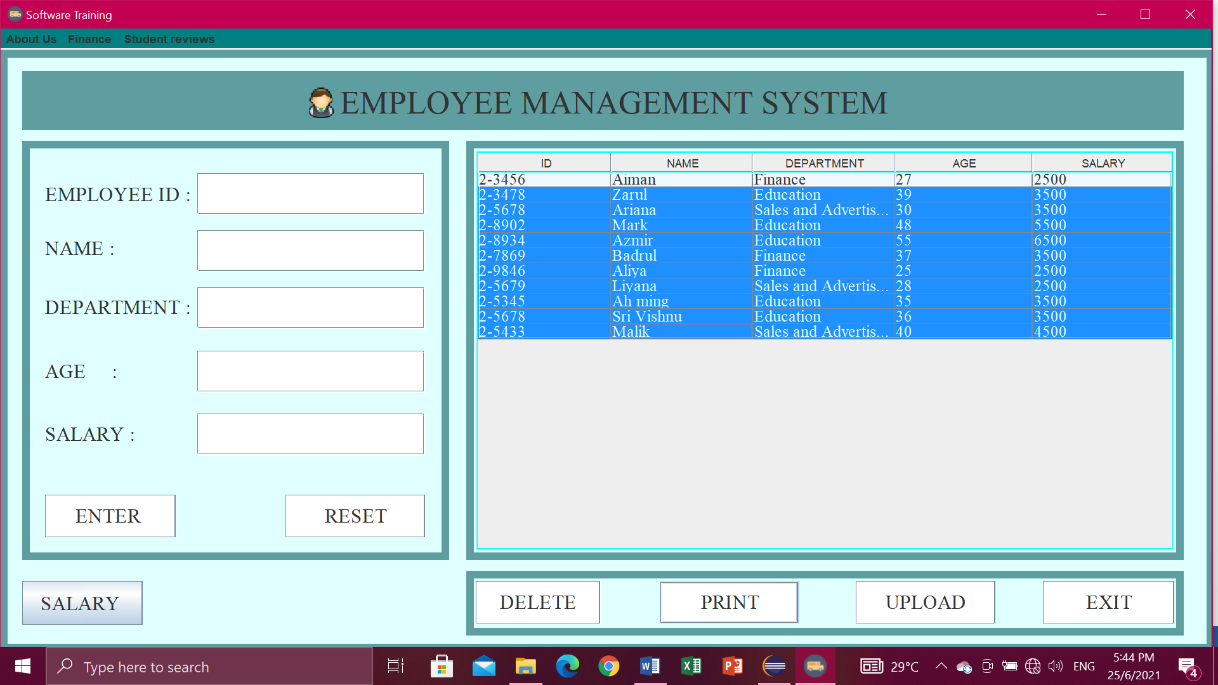

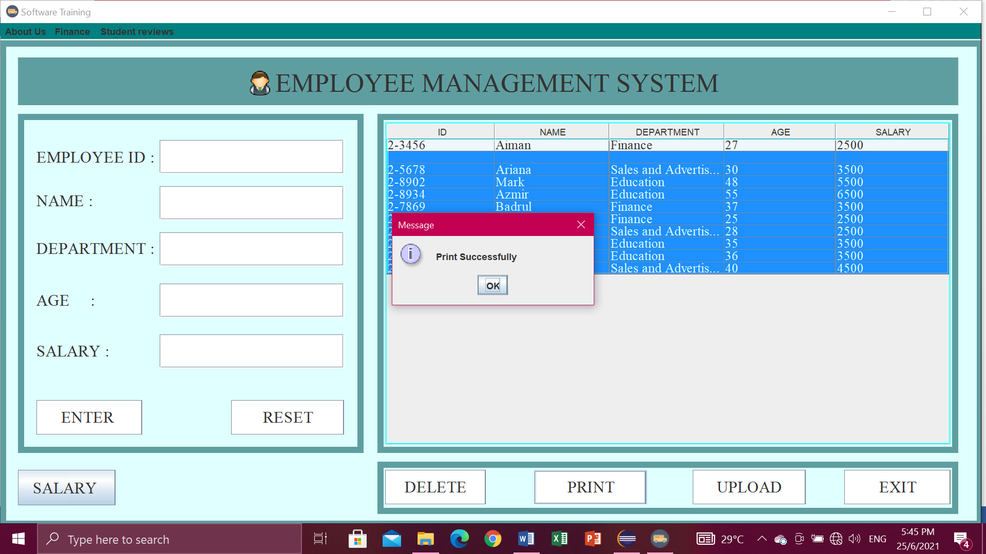

Salary button

* Display the Total Amount of Salary and appear "Total Salary".

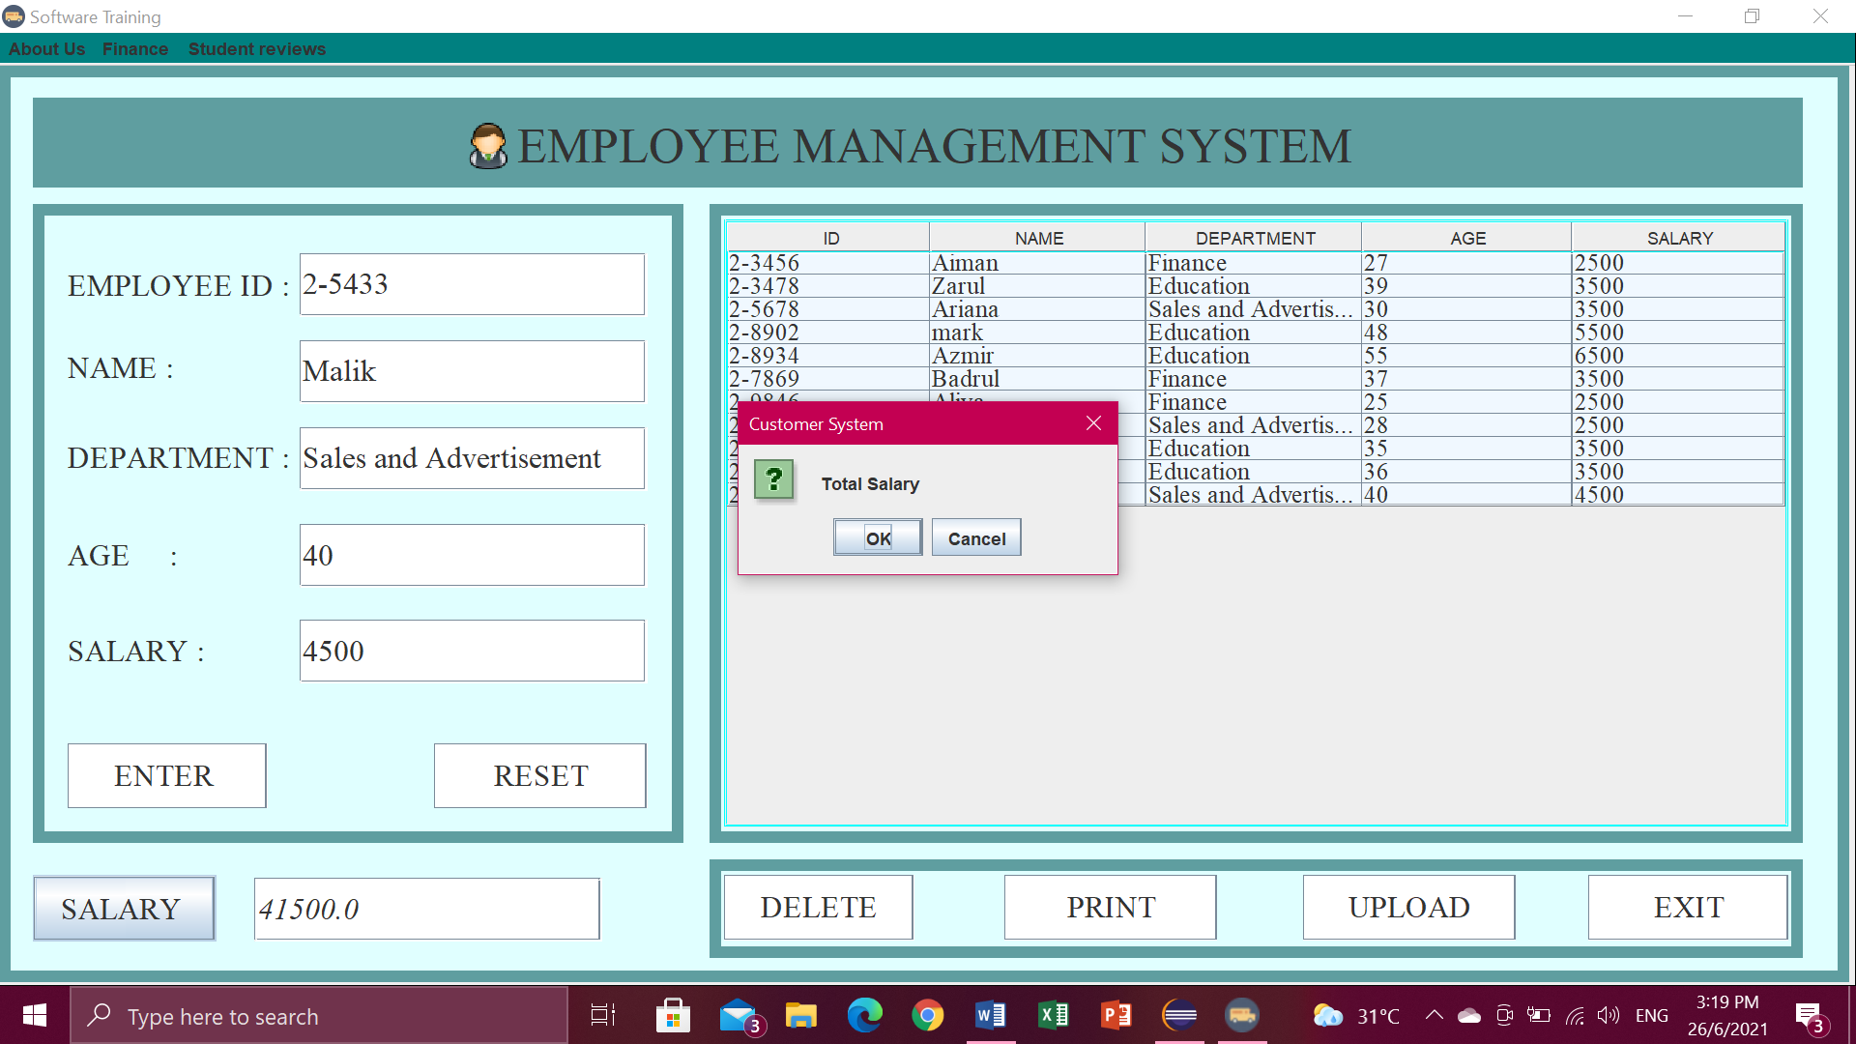

Exit button

* If you are click exit button, it will pop-up” Confirm if you want to exit ”. Then just click Yes or No.

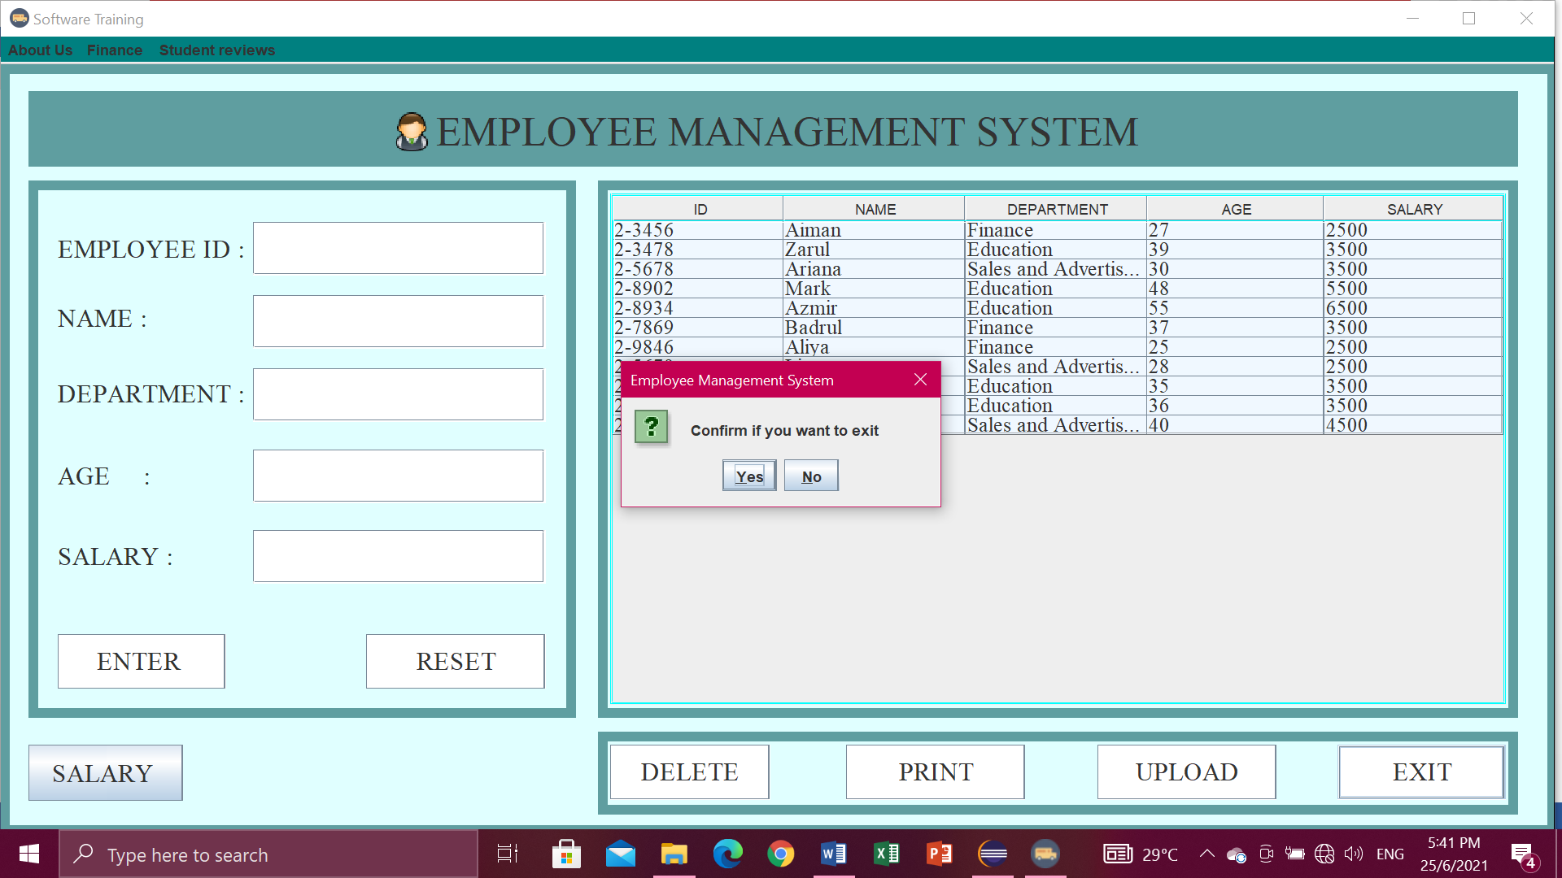

Menu bar.

* For the menu bars, you can click

1. About Us , in the menu item contains Intelleq Qs and Employee,
2. Finance, contains finance and sales,
3. Student reviews, contain Advertisement.

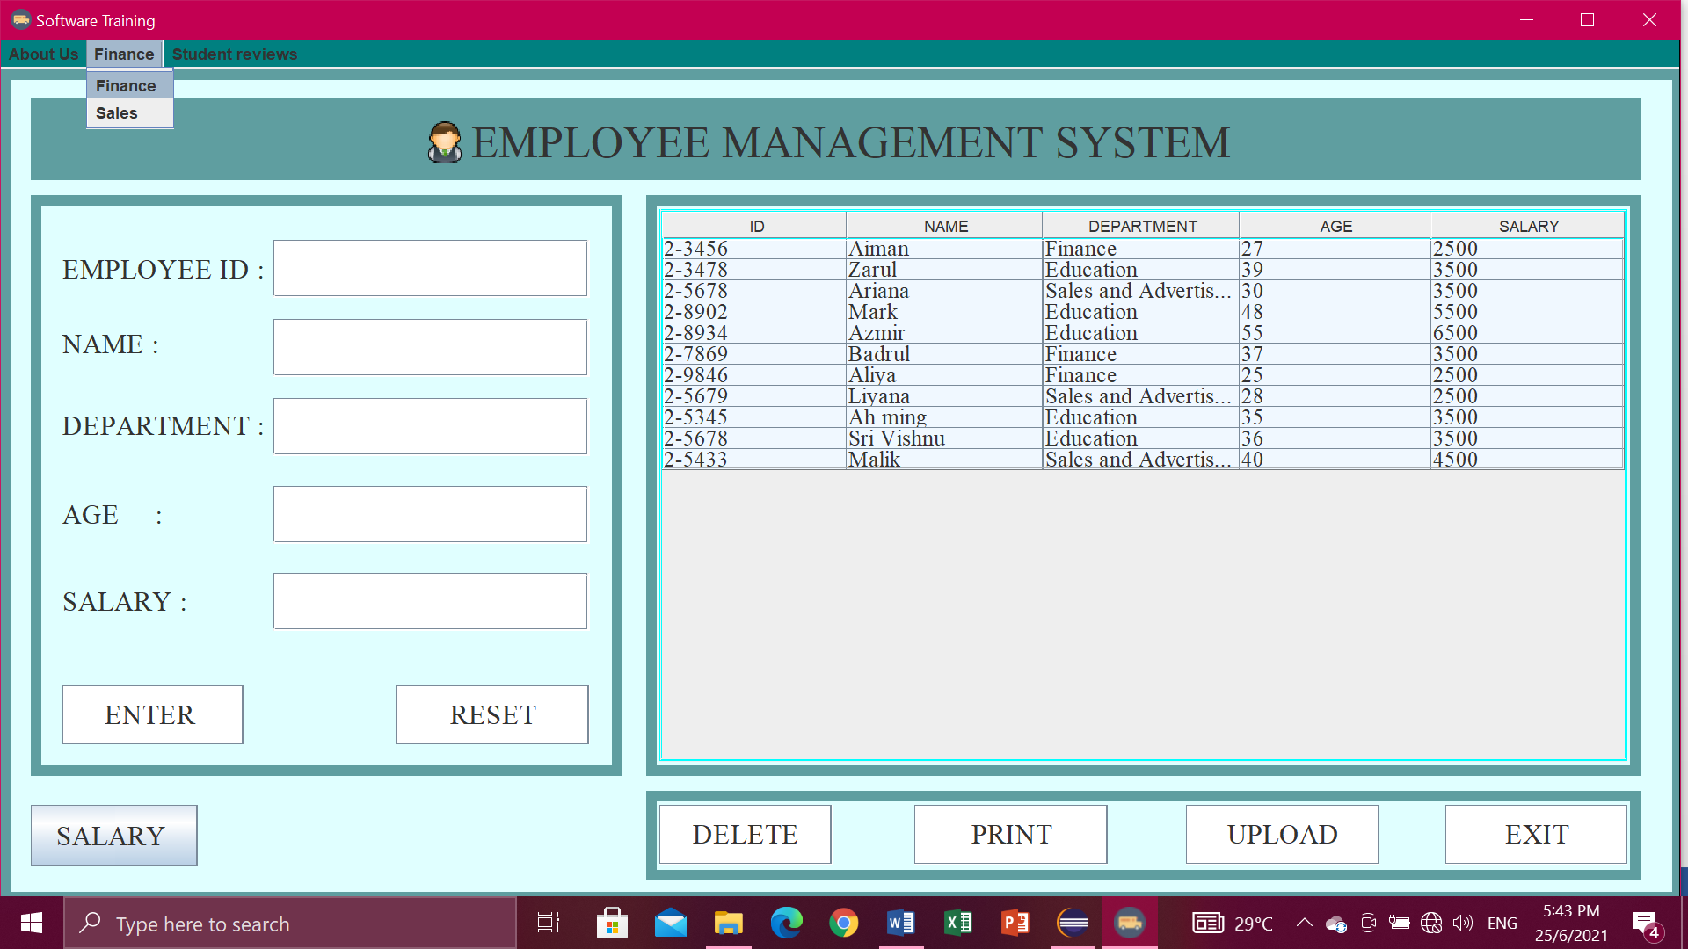

**Finance**

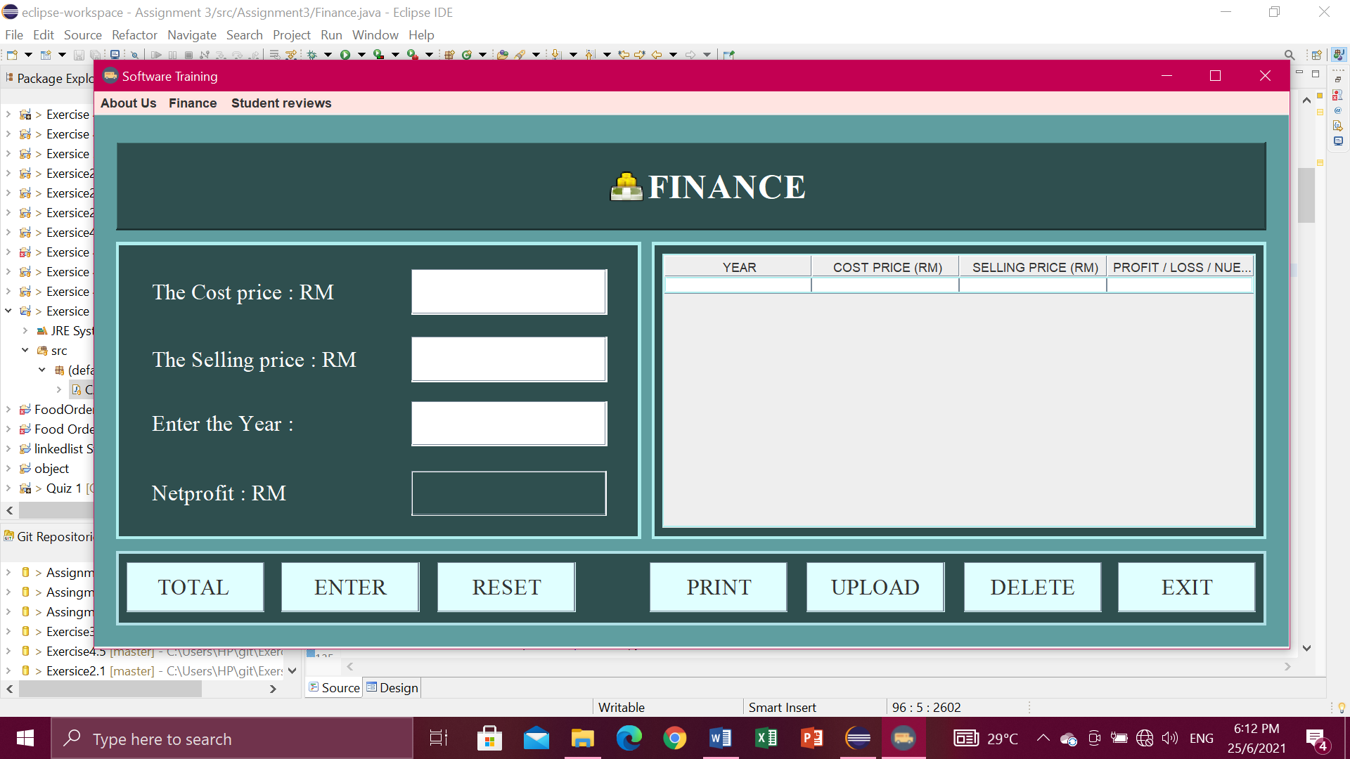

Total button

* First enter the cost price, enter the selling price, enter the year, and then click button TOTAL to get the total netprofit.

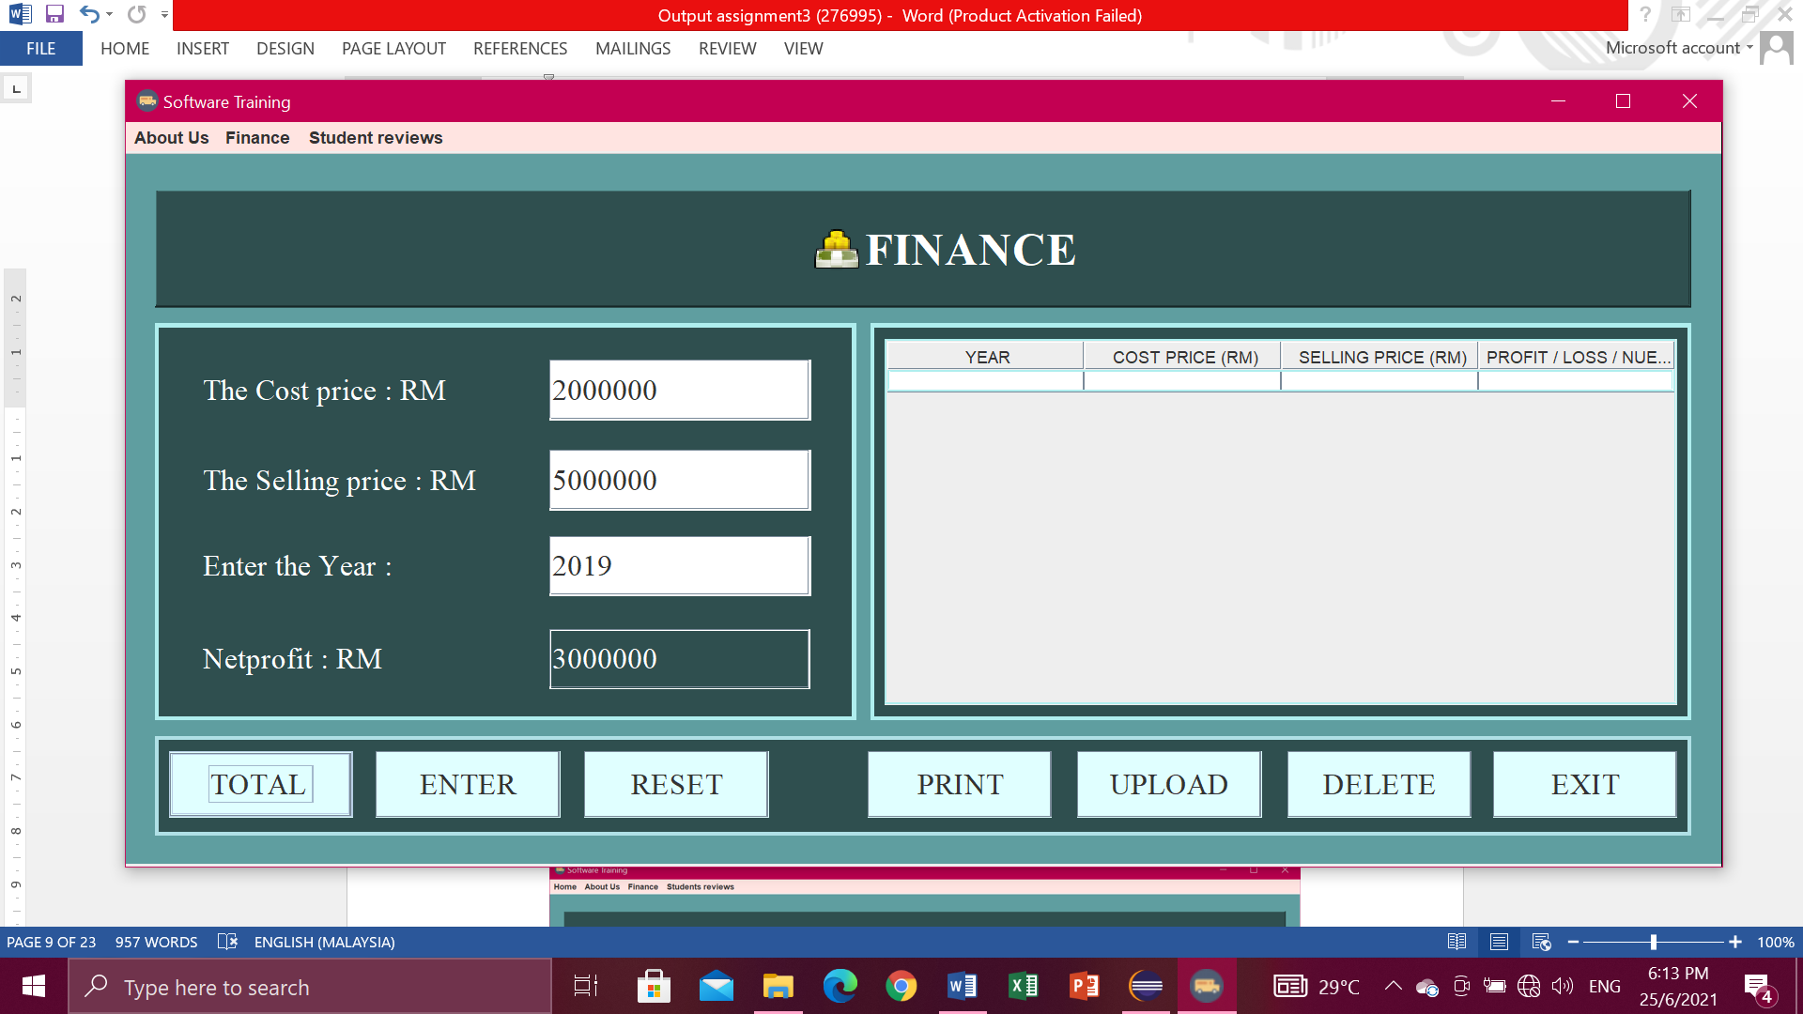

Enter button

* After click button TOTAL, you have to click button ENTER to display in the table.

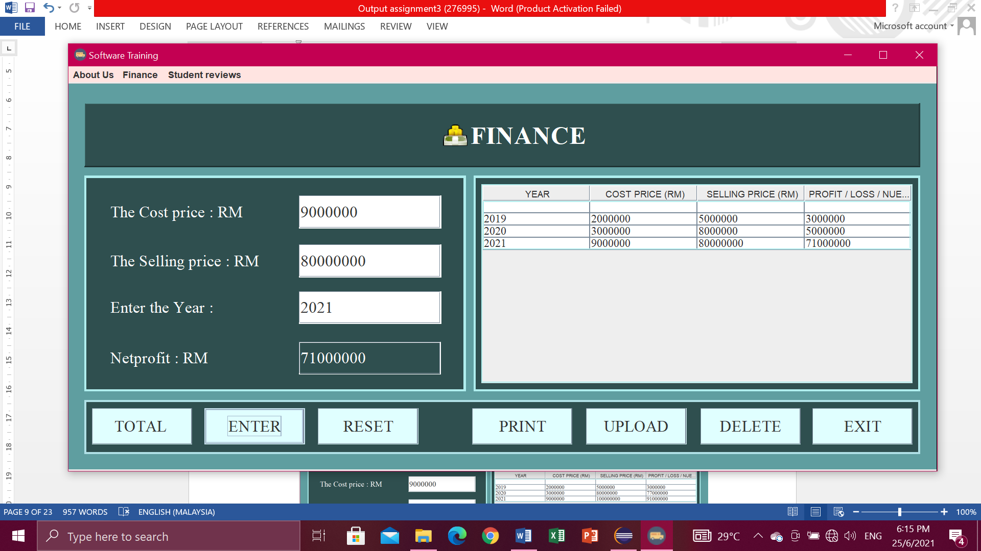

Reset button

* Click button RESET when don’t write data or key in data. So you don’t have to clean one by one.

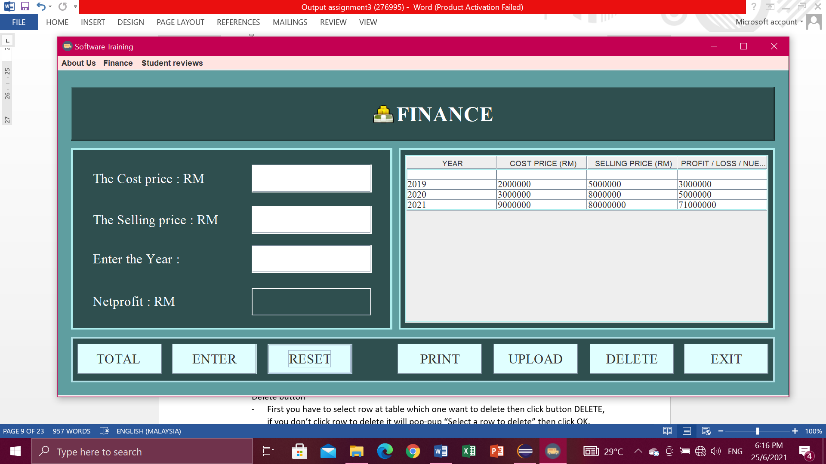

Delete button

* First you have to select row at table which one want to delete then click button DELETE, if you don’t click row to delete it will pop-up “Select a row to delete” then click OK.

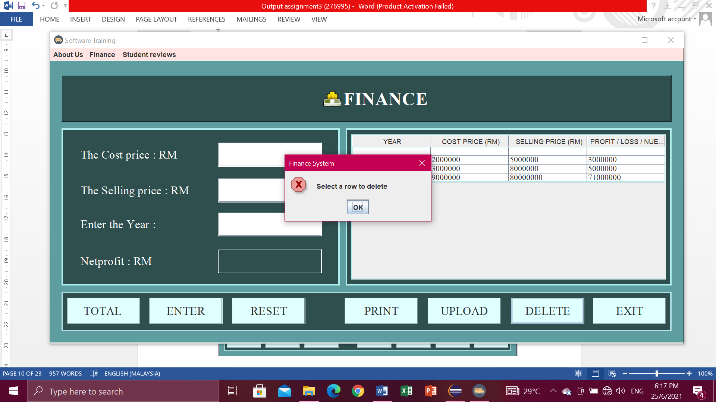

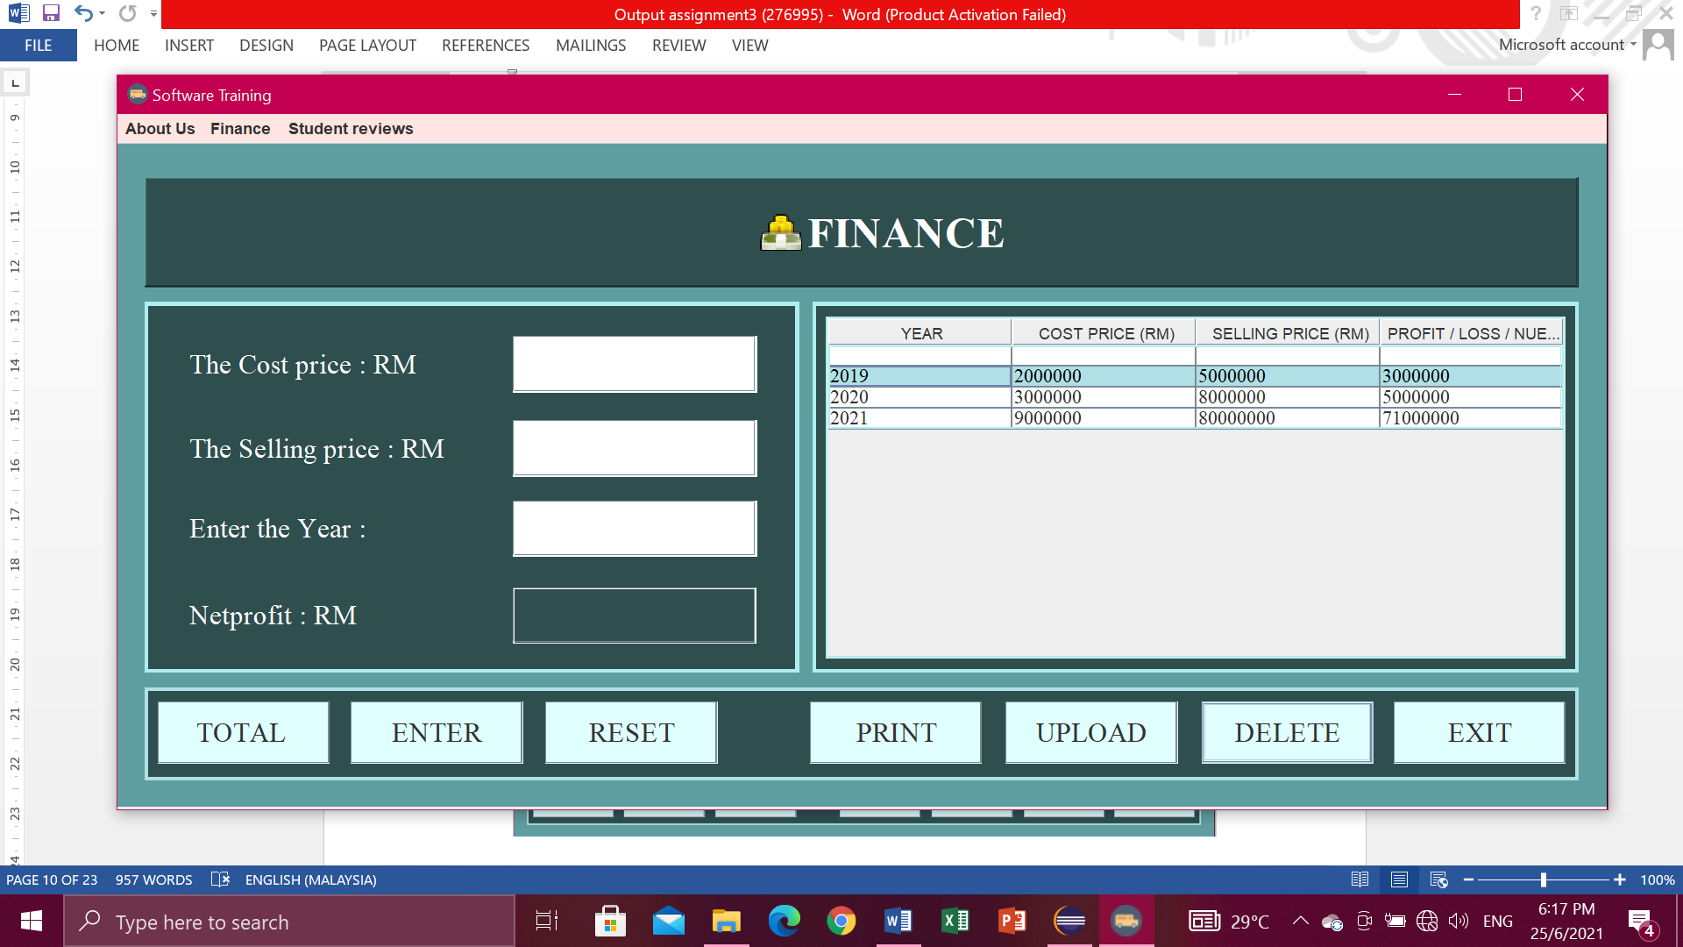

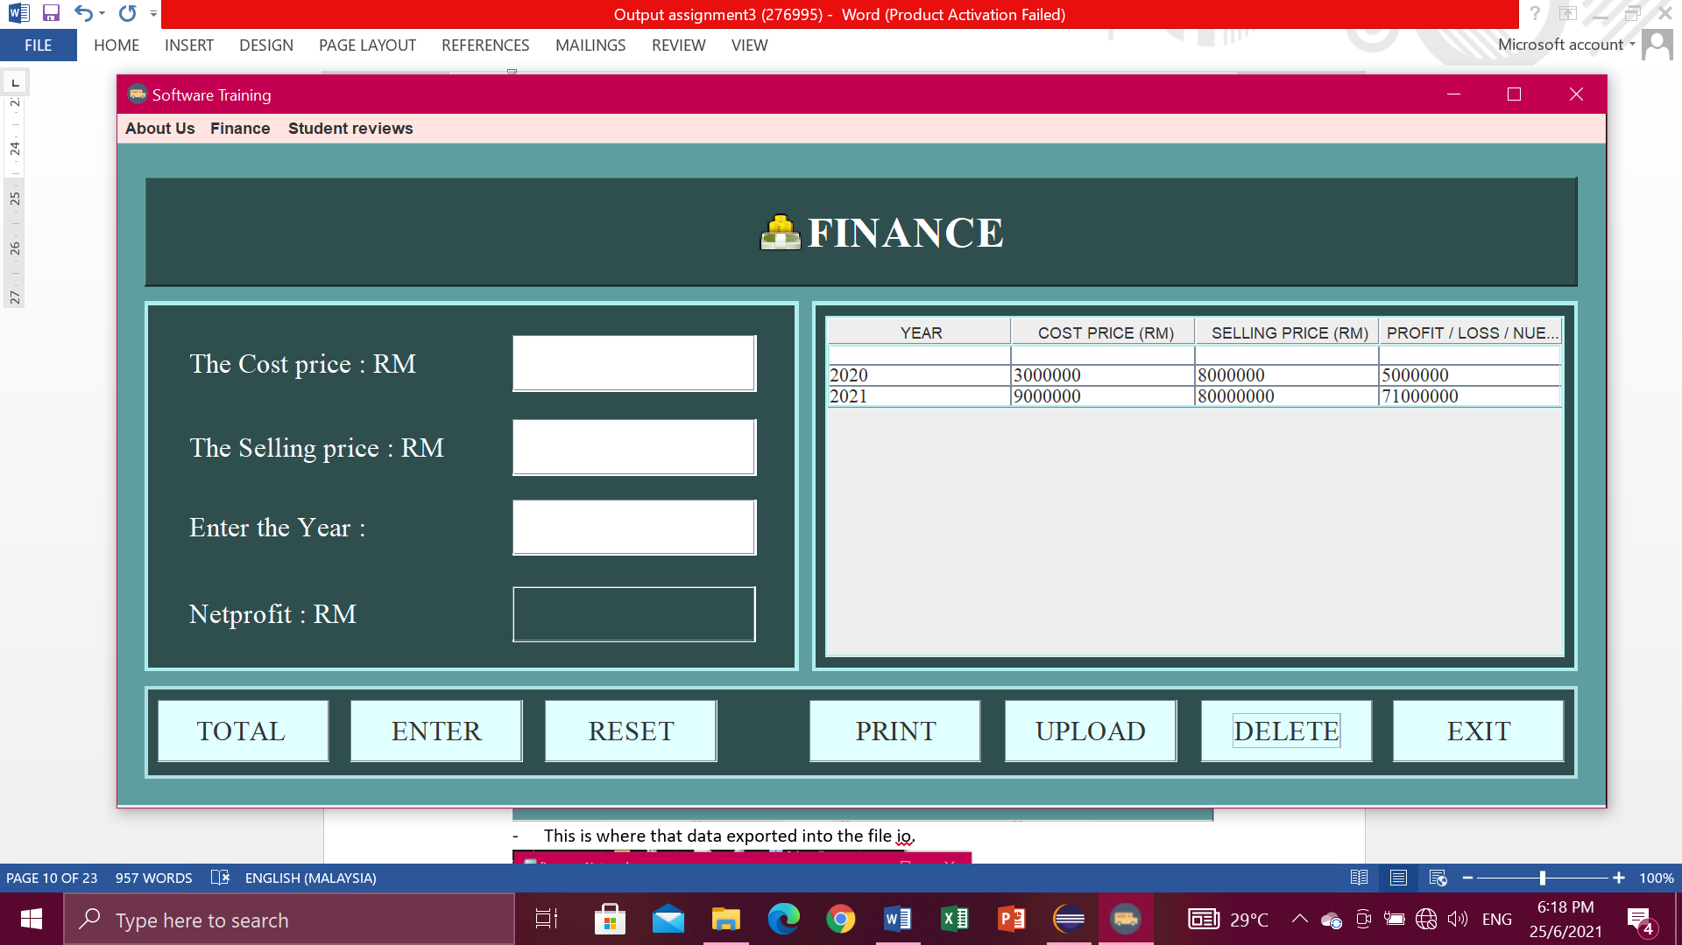

Upload button

* Click button UPLOAD. Then will pop-up “Data Exported”.

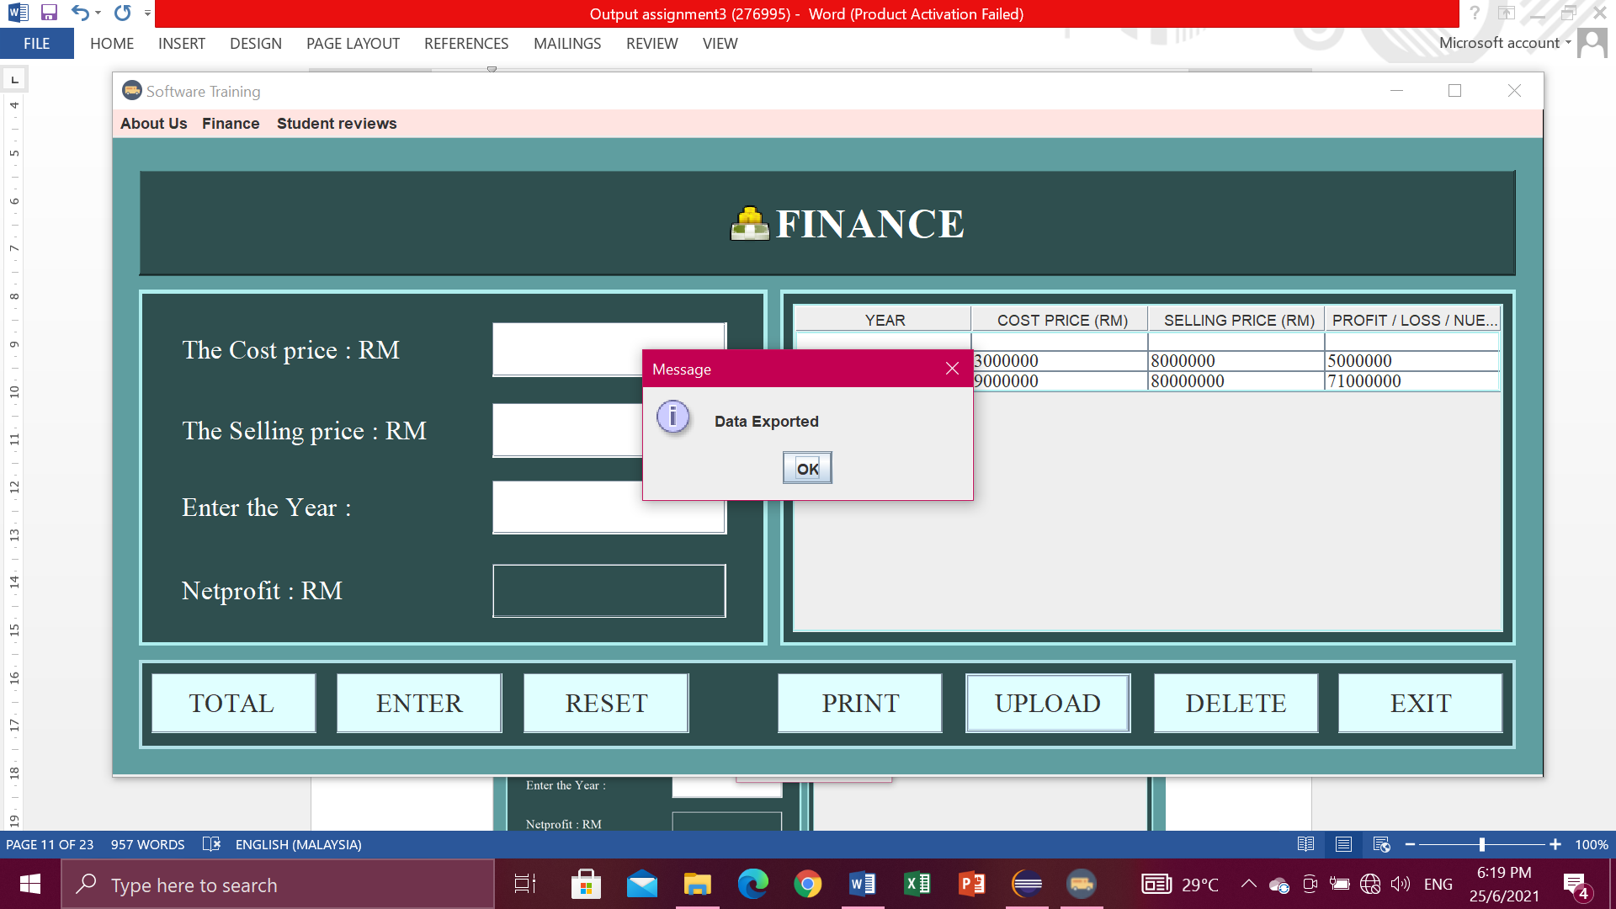

* Data exported into the file io.

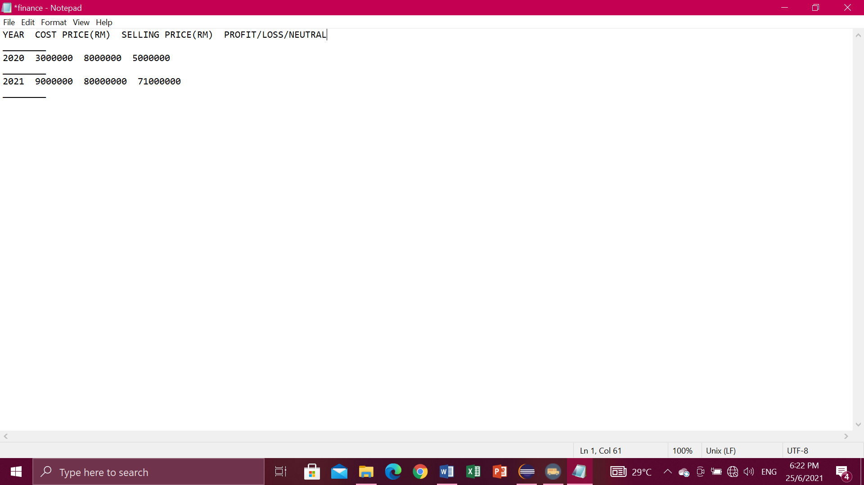

Print button

* You have to select a row first.

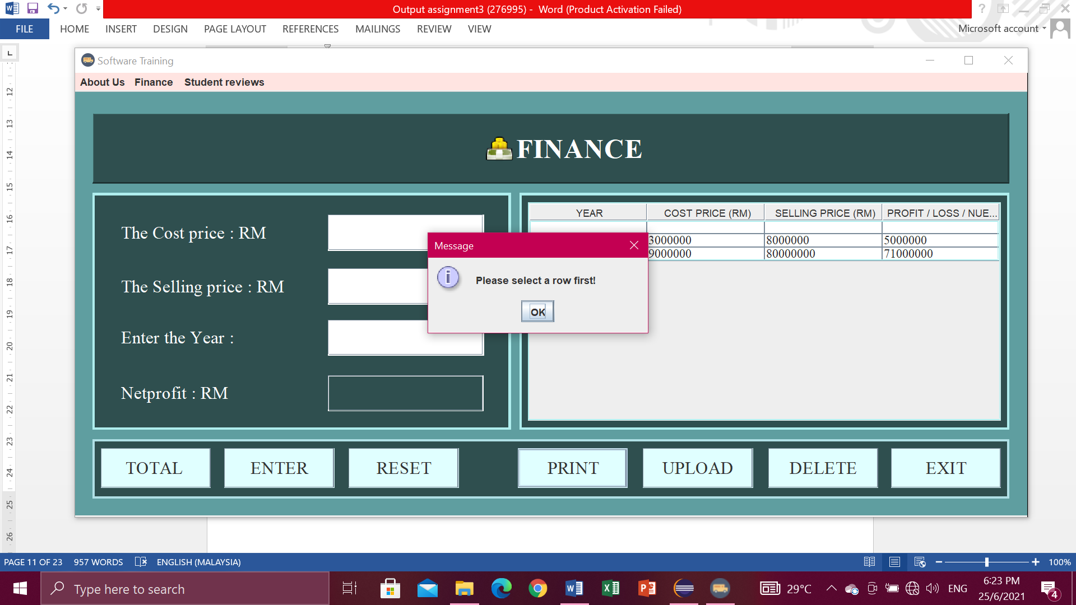

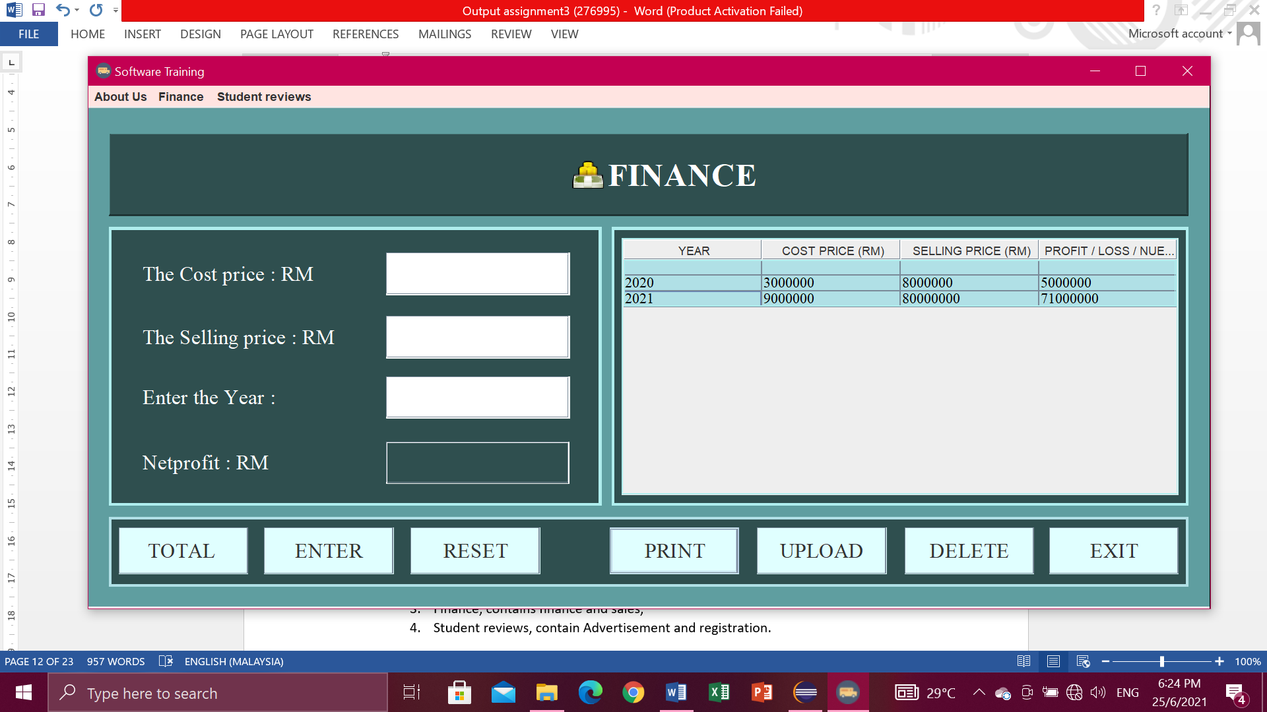

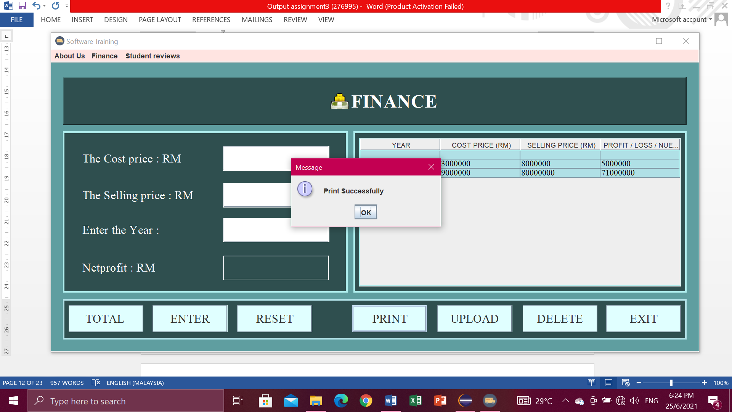

Menu bar.

* For the menu bars, you can click

1. About Us , in the menu item contains Intelleq Qs and Employee,
2. Finance, contains finance and sales,
3. Student reviews, contain Advertisement.

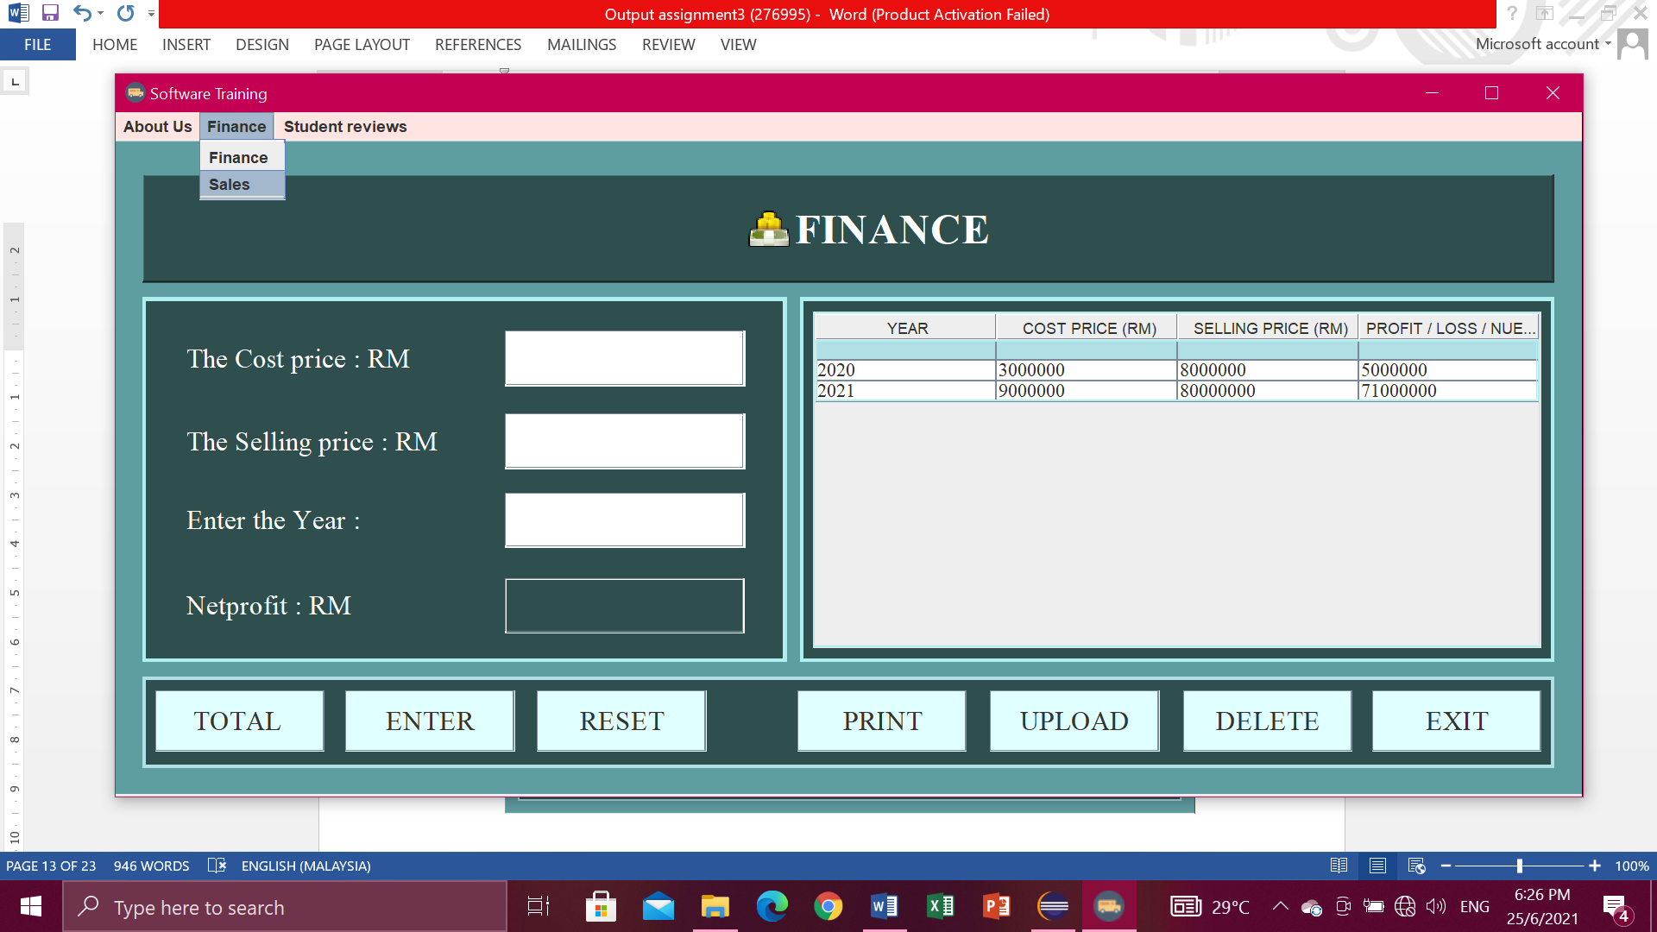

Exit button

* If you are click exit button, it will pop-up ” Confirm if you want to exit ”.Then just click Yes or No.

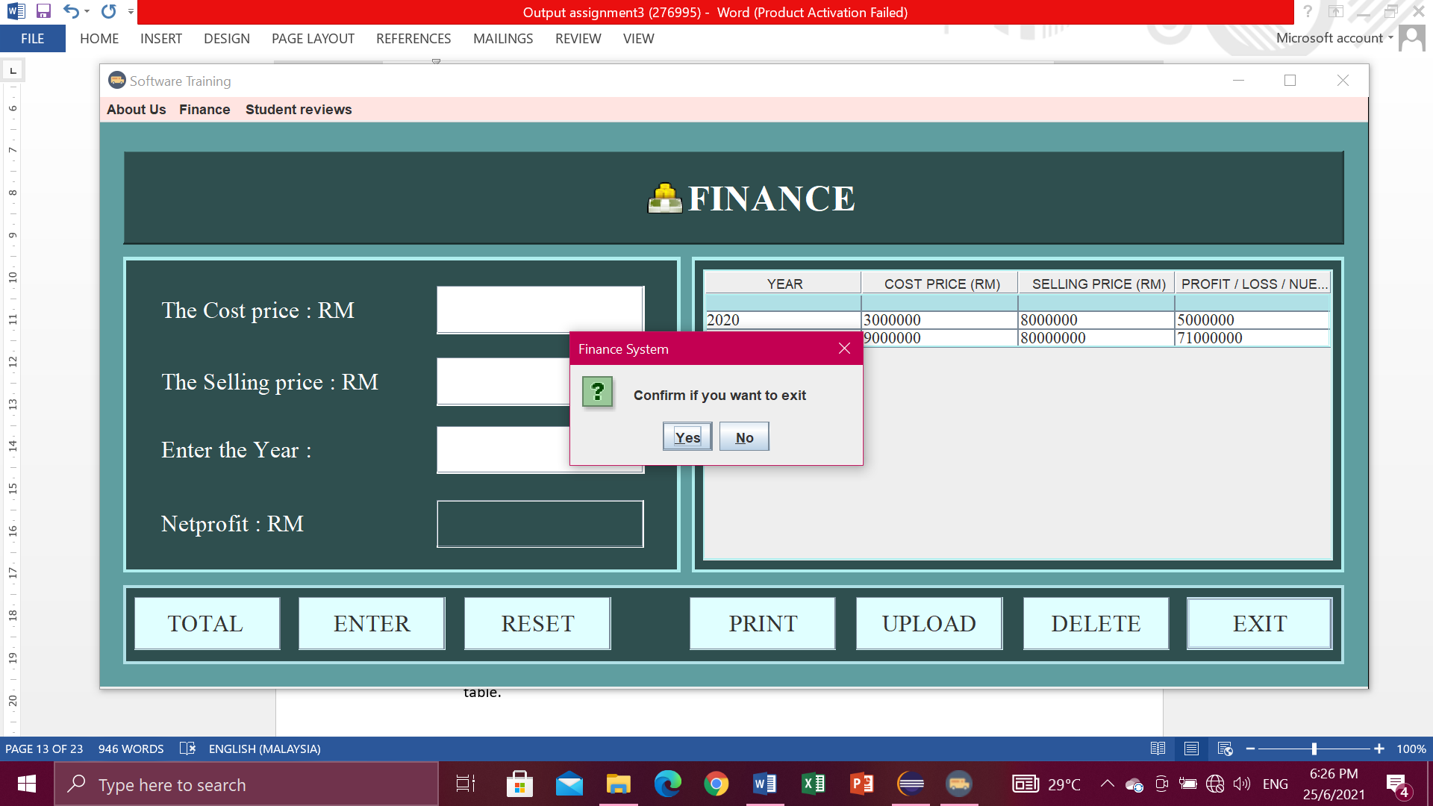

**Sales**

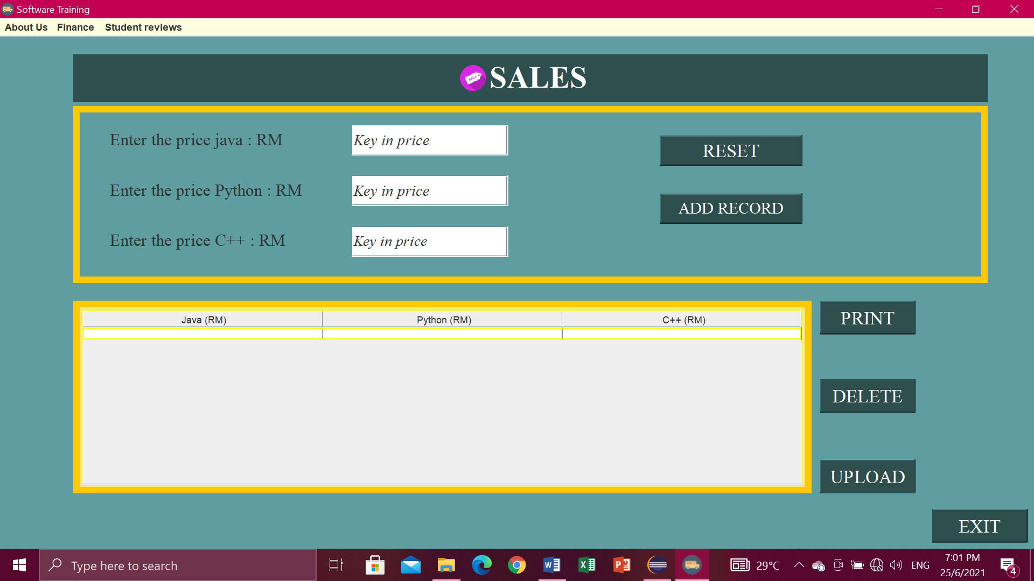

Add record button

* This button will pass the value to the customer and this button also will display in the table.

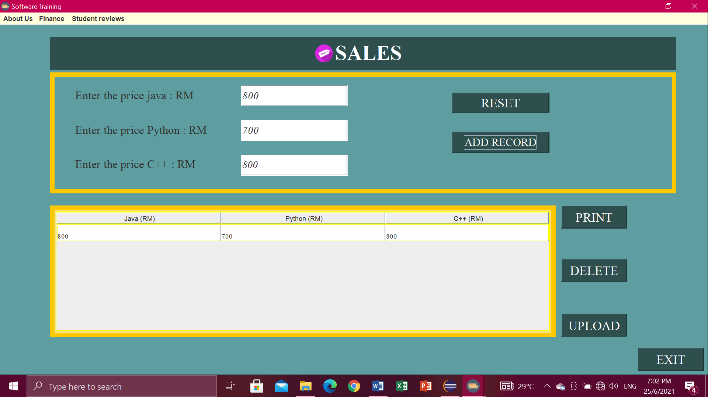

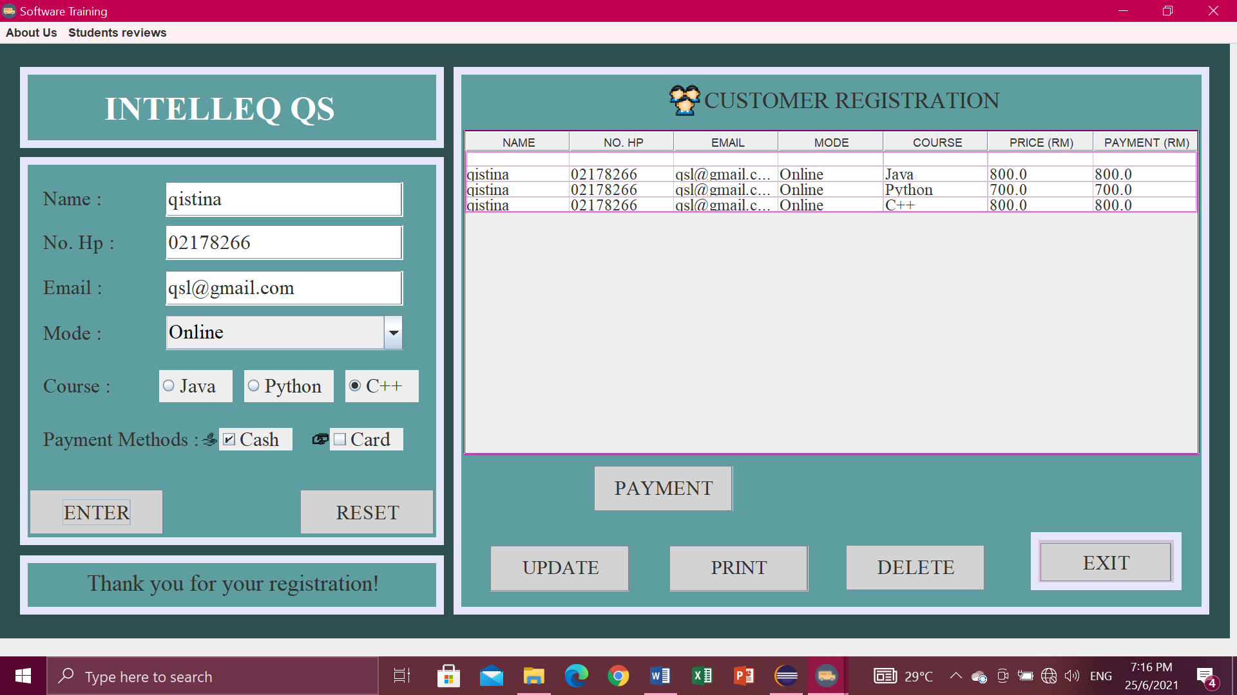

Delete button

* First you have to select row at table which one want to delete then click button DELETE, if you don’t click row to delete it will pop-up “Select a row to delete” then click OK.

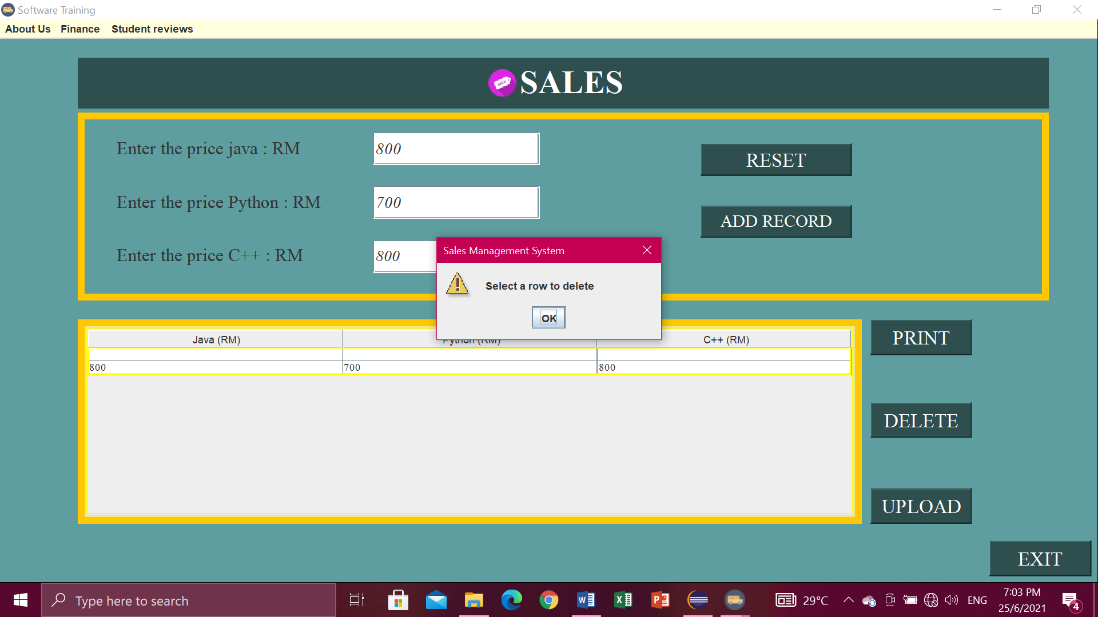

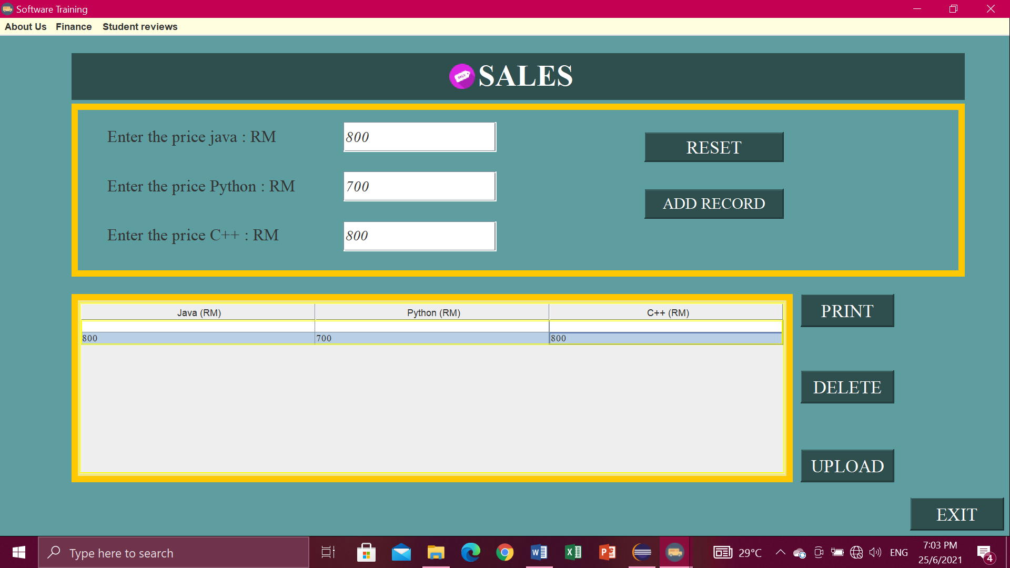

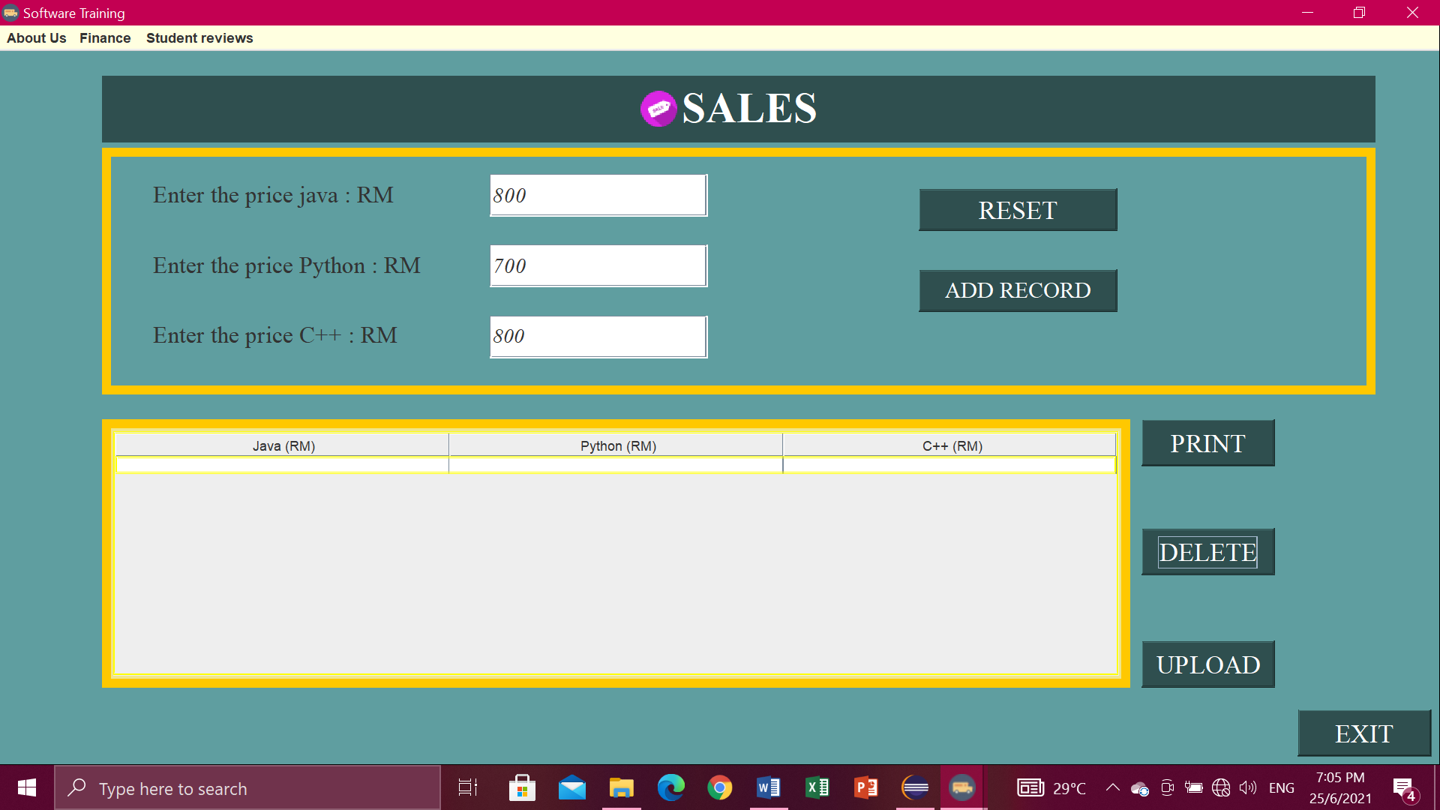

* If you click button DELETE but no data in table it will pop-up“No data to delete”.

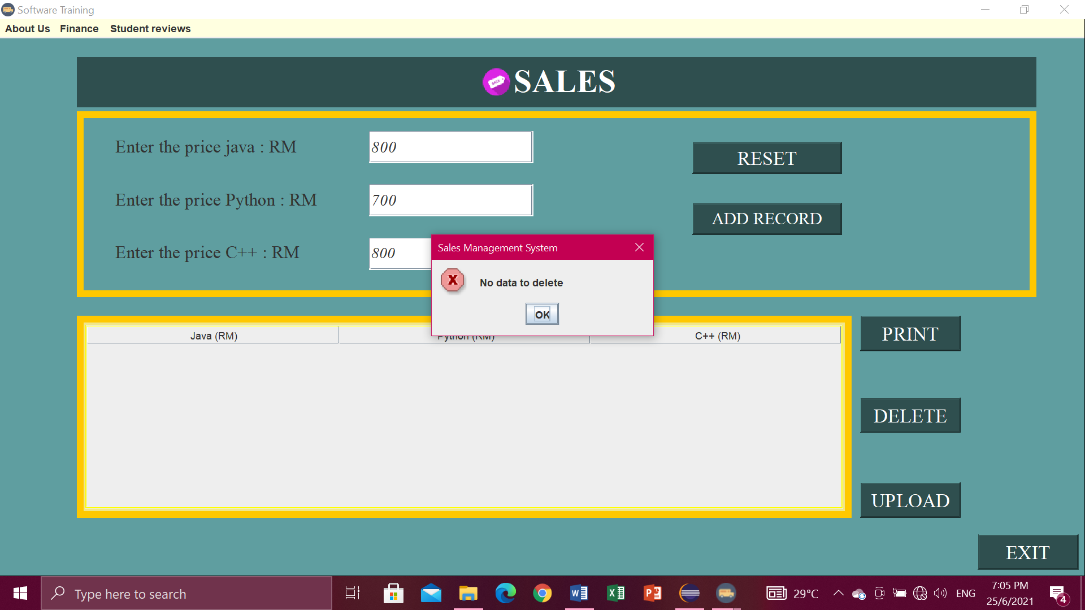

Reset button

* Click button RESET when don’t write data or key in data. So you don’t have to clean one by one.

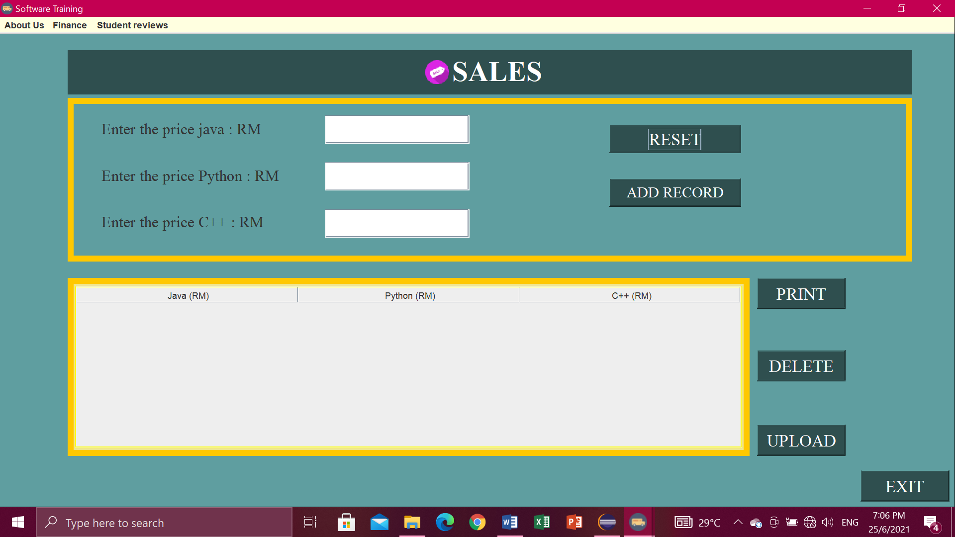

Upload button

* Click button UPLOAD. Then will pop-up “Data Exported”.

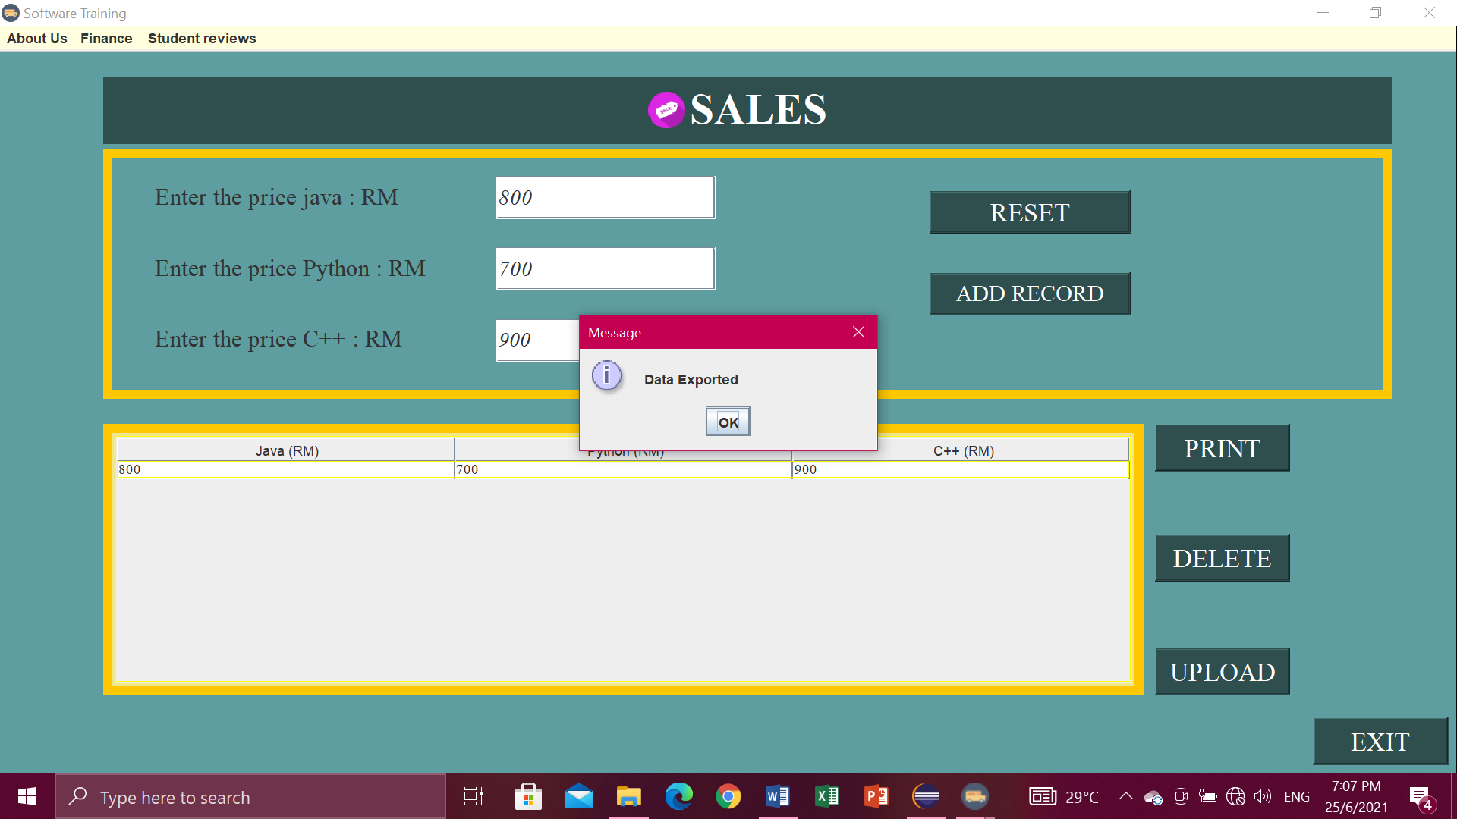

* The data exported into the file io.

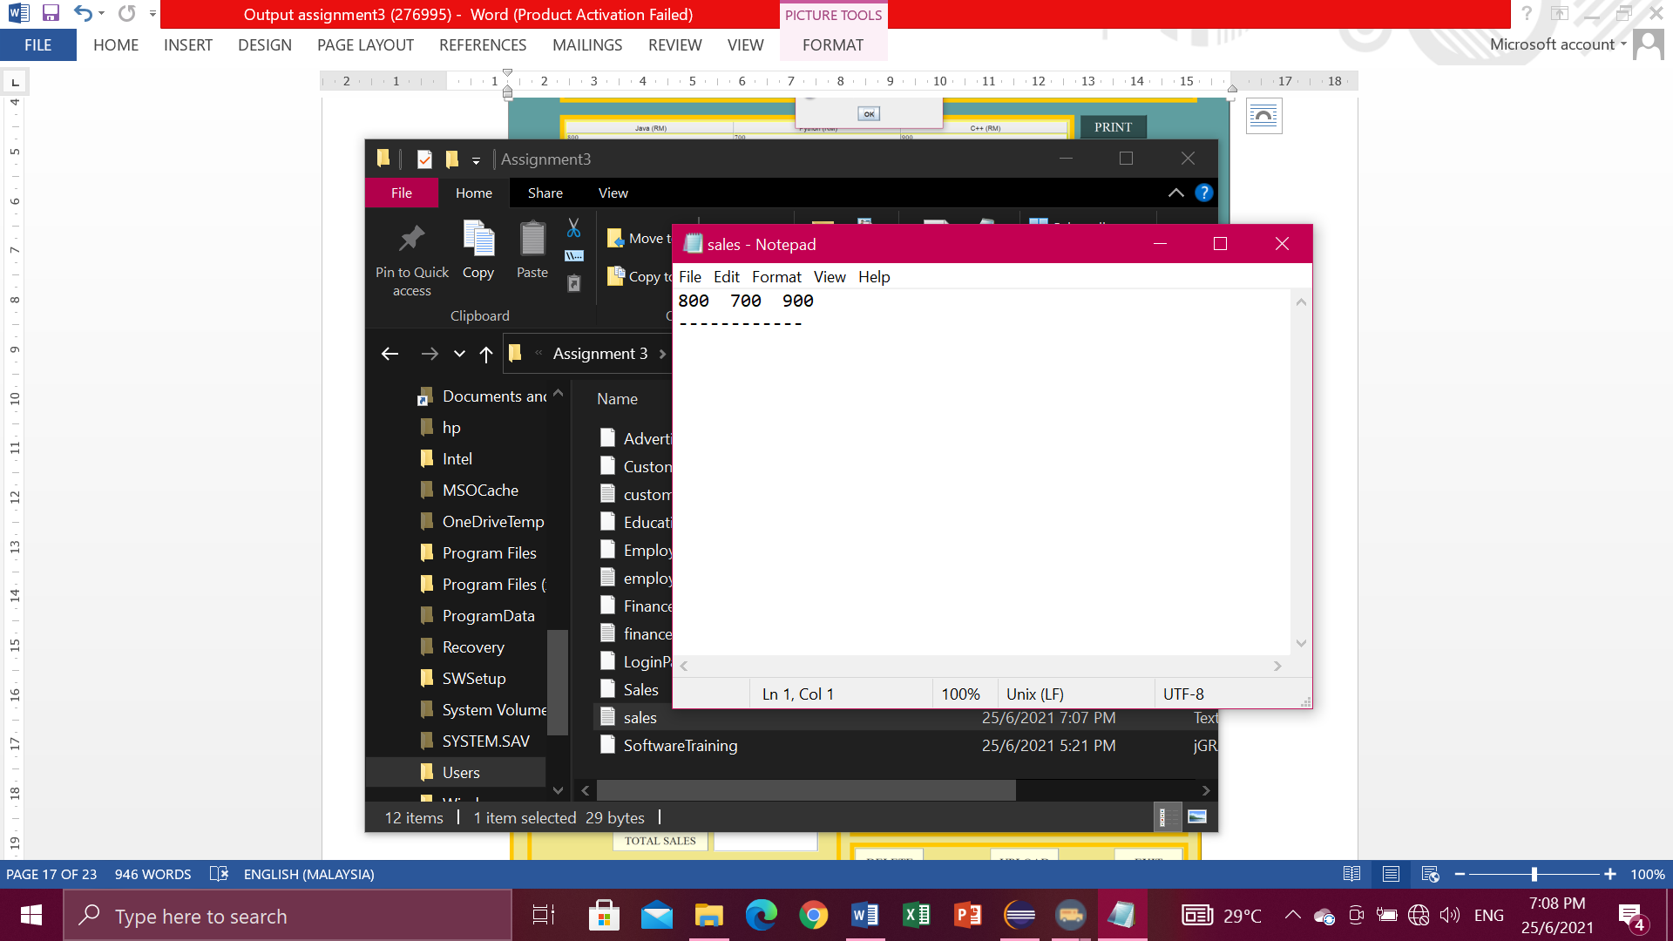

Print button

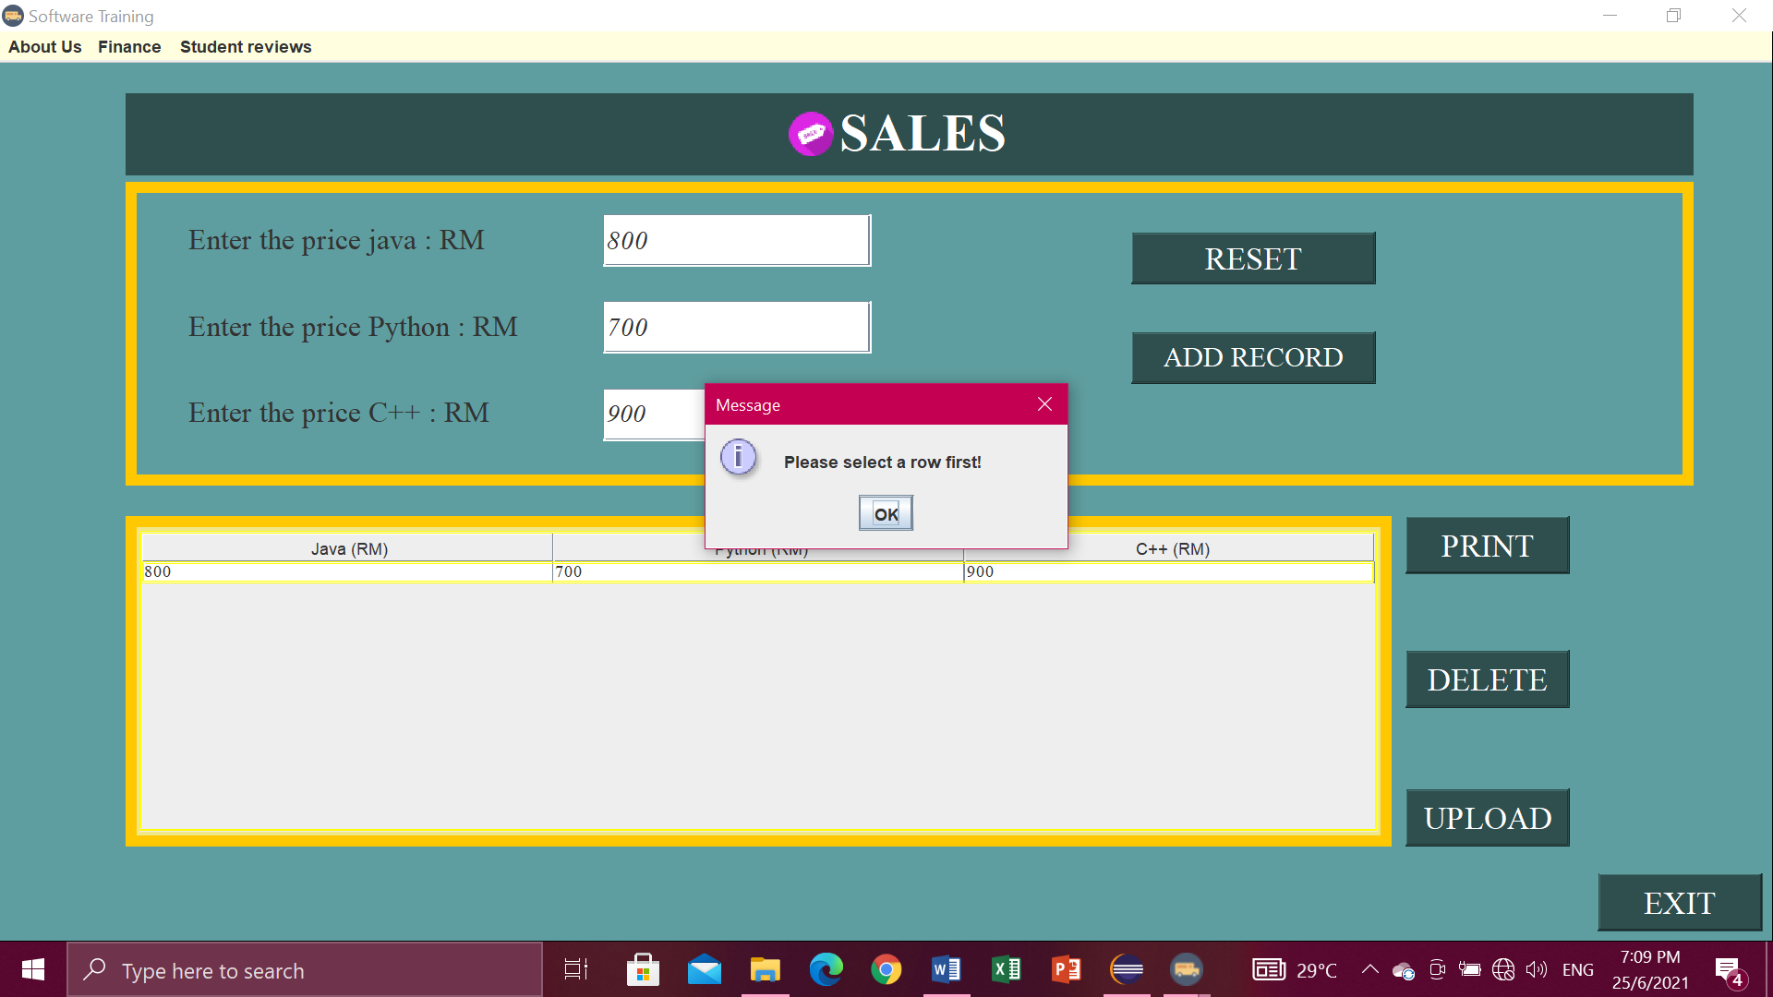

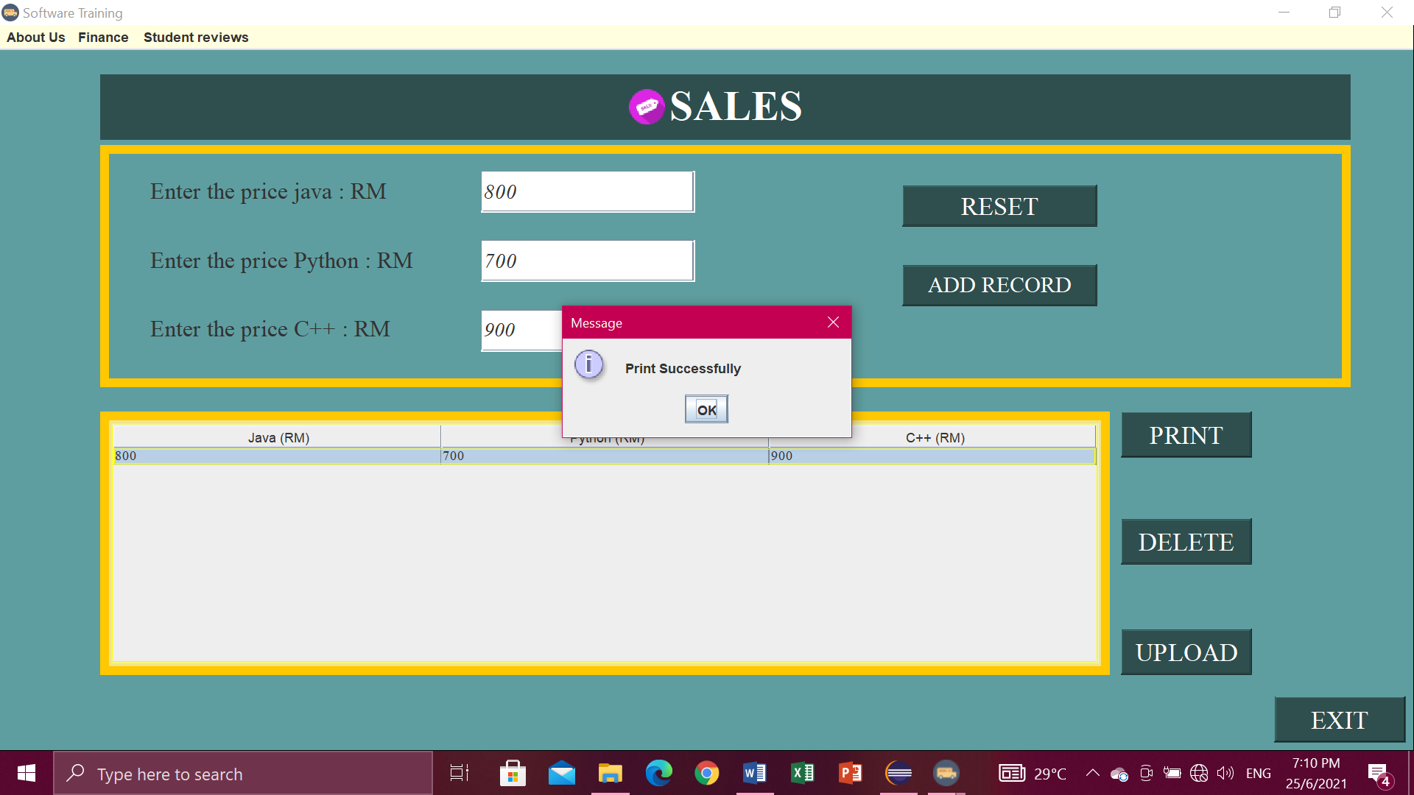

Menu bar.

* For the menu bars, you can click

1. About Us , in the menu item contains Intelleq Qs and Employee,
2. Finance, contains finance and sales,
3. Student reviews, contain Advertisement.

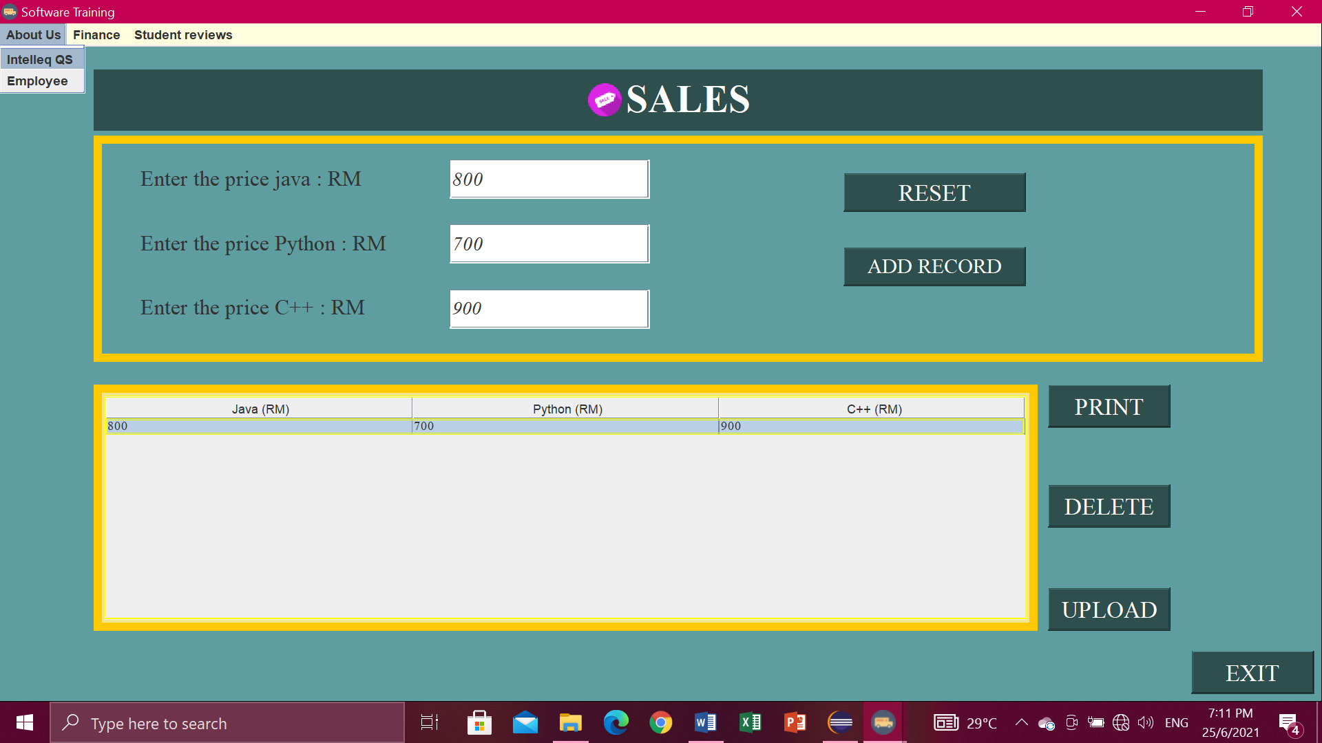

Exit button

* If you are click exit button, it will pop-up” Confirm if you want to exit ”. Then just click Yes or No.

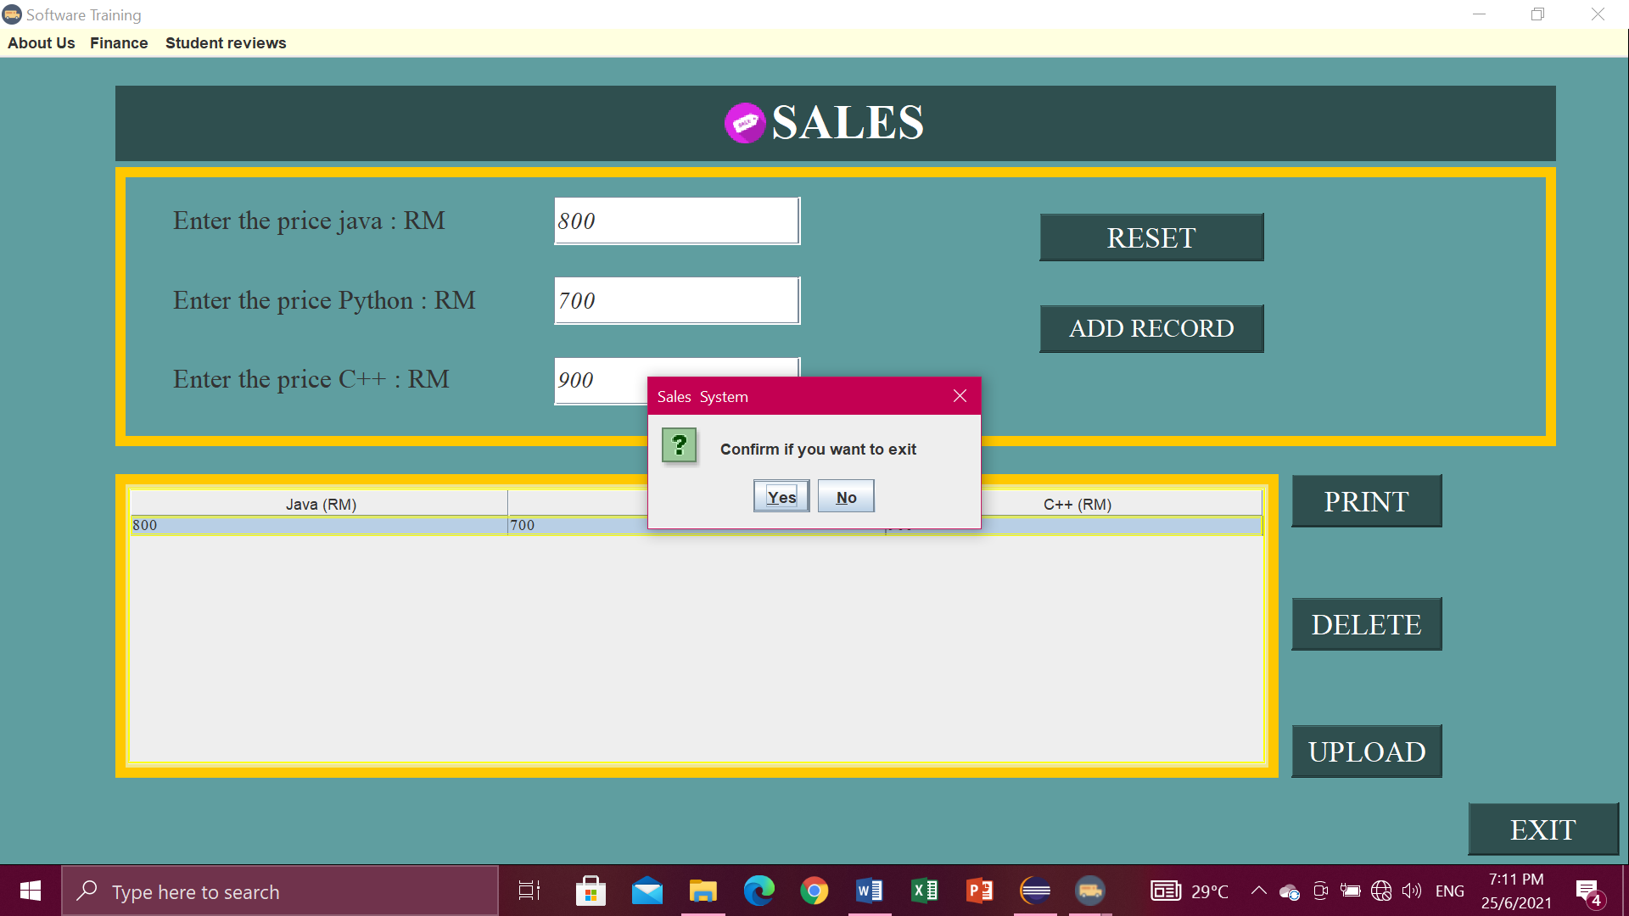

**Advertisement**

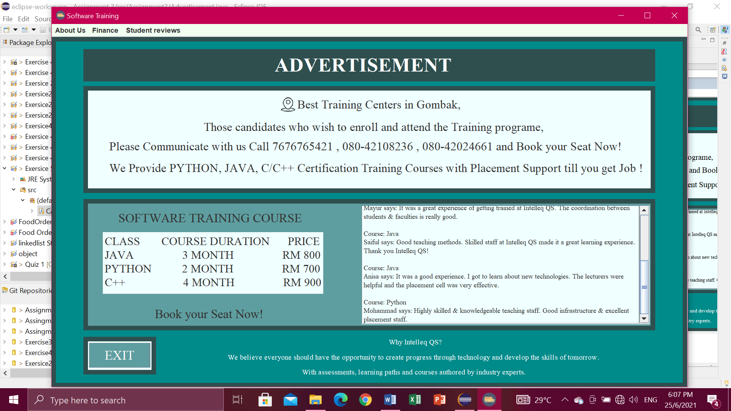

Exit button

* If you are click exit button, it will pop-up” Confirm if you want to exit ”. Then just click Yes or No.

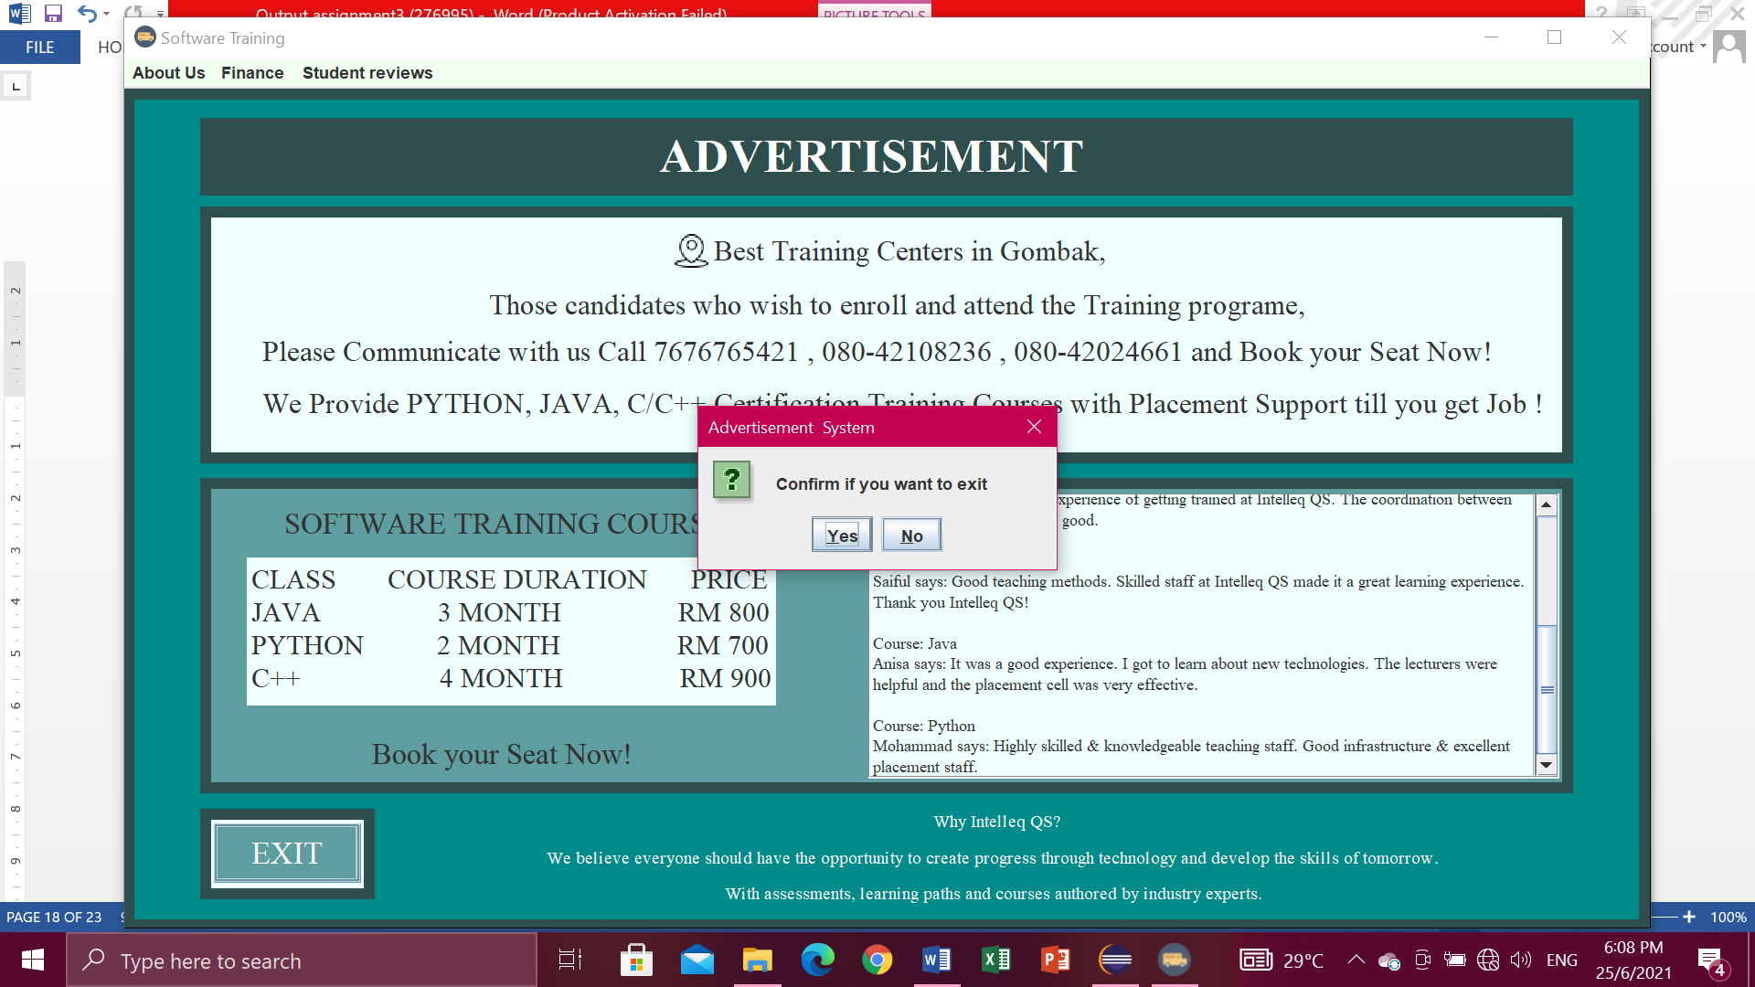

Menu bar

* For the menu bars, you can click

1. About Us , in the menu item contains Intelleq Qs and Employee,
2. Finance, contains finance and sales,
3. Student reviews, contain Advertisement.

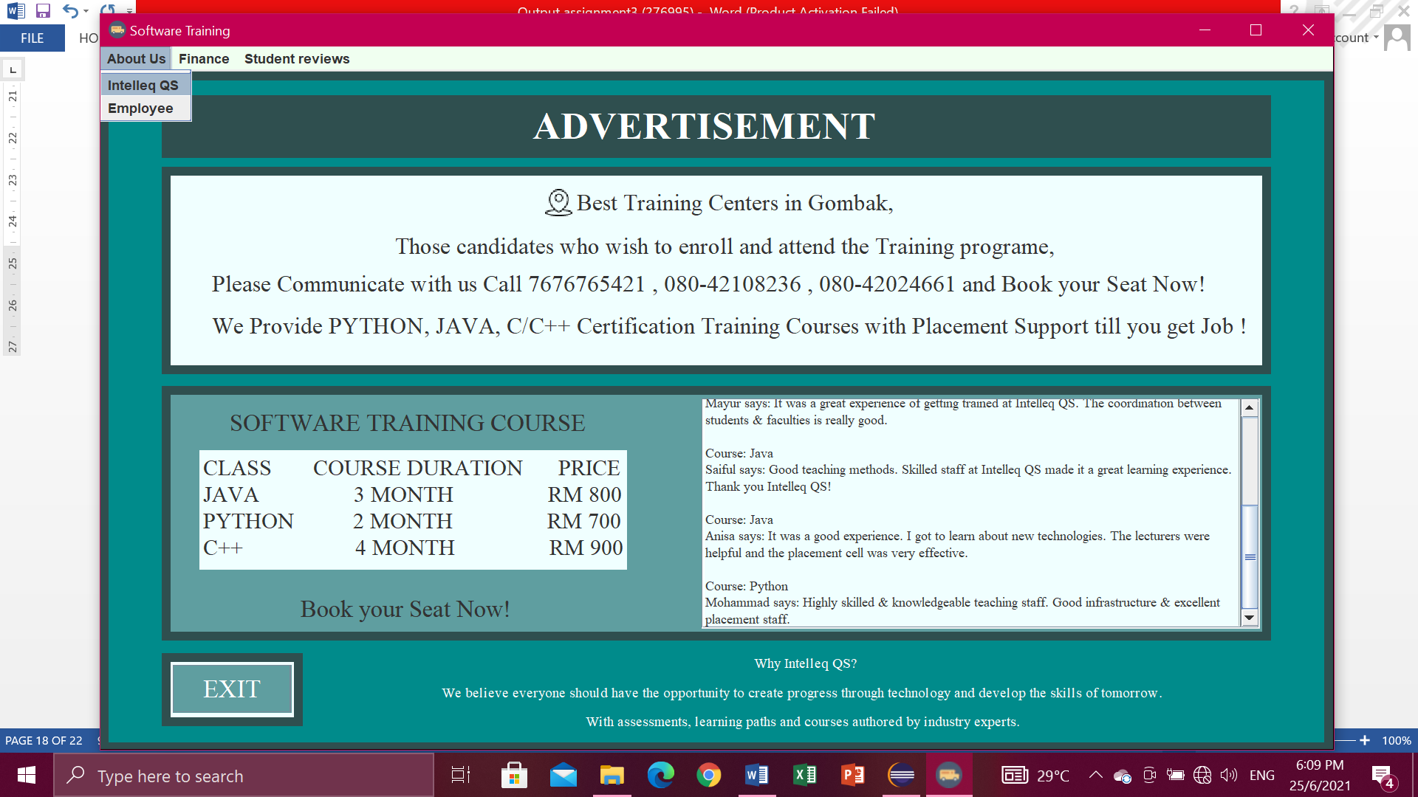

1. **(USER BUTTON) – Customer**

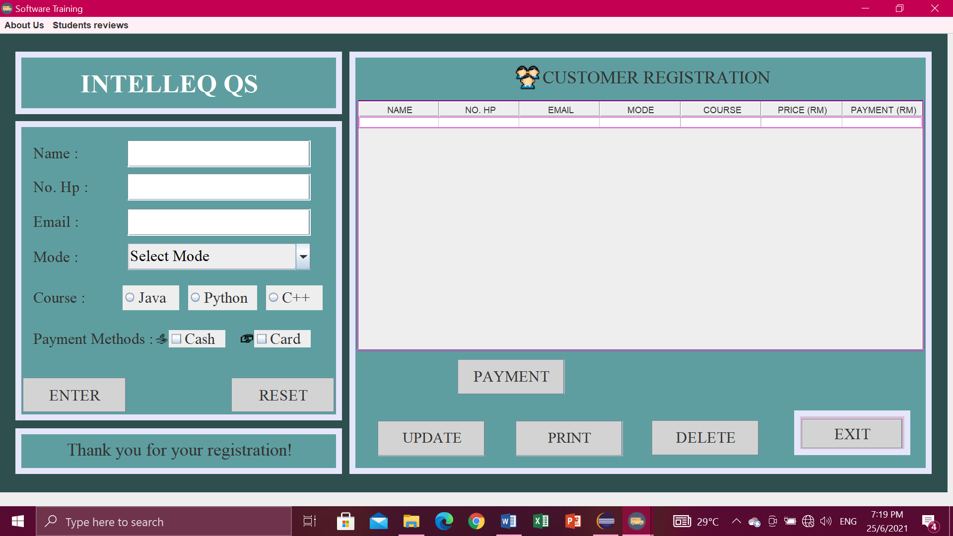

Enter button

* Enter Name, No. Hp, Email, Choose Mode, Course and Payment Methods. Then click button Enter. After click Enter it will display in the table.

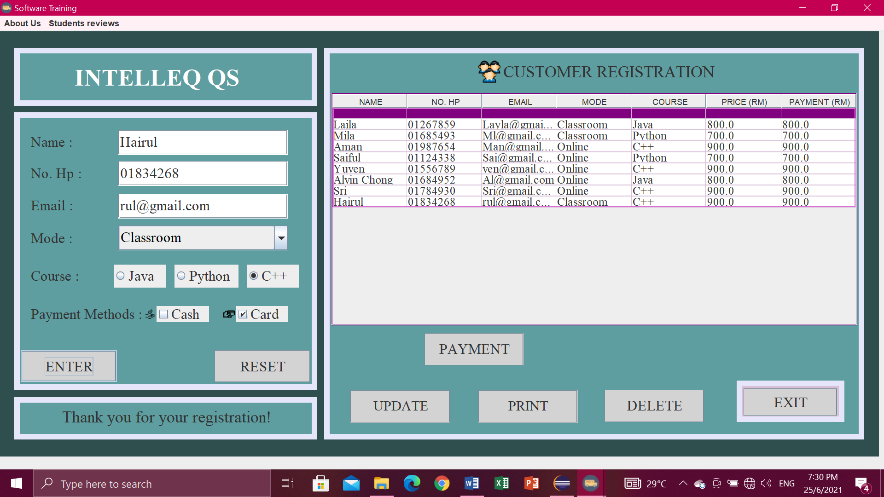

Reset button

* Click button RESET when don’t write data or key in data. So you don’t have to clean one by one.

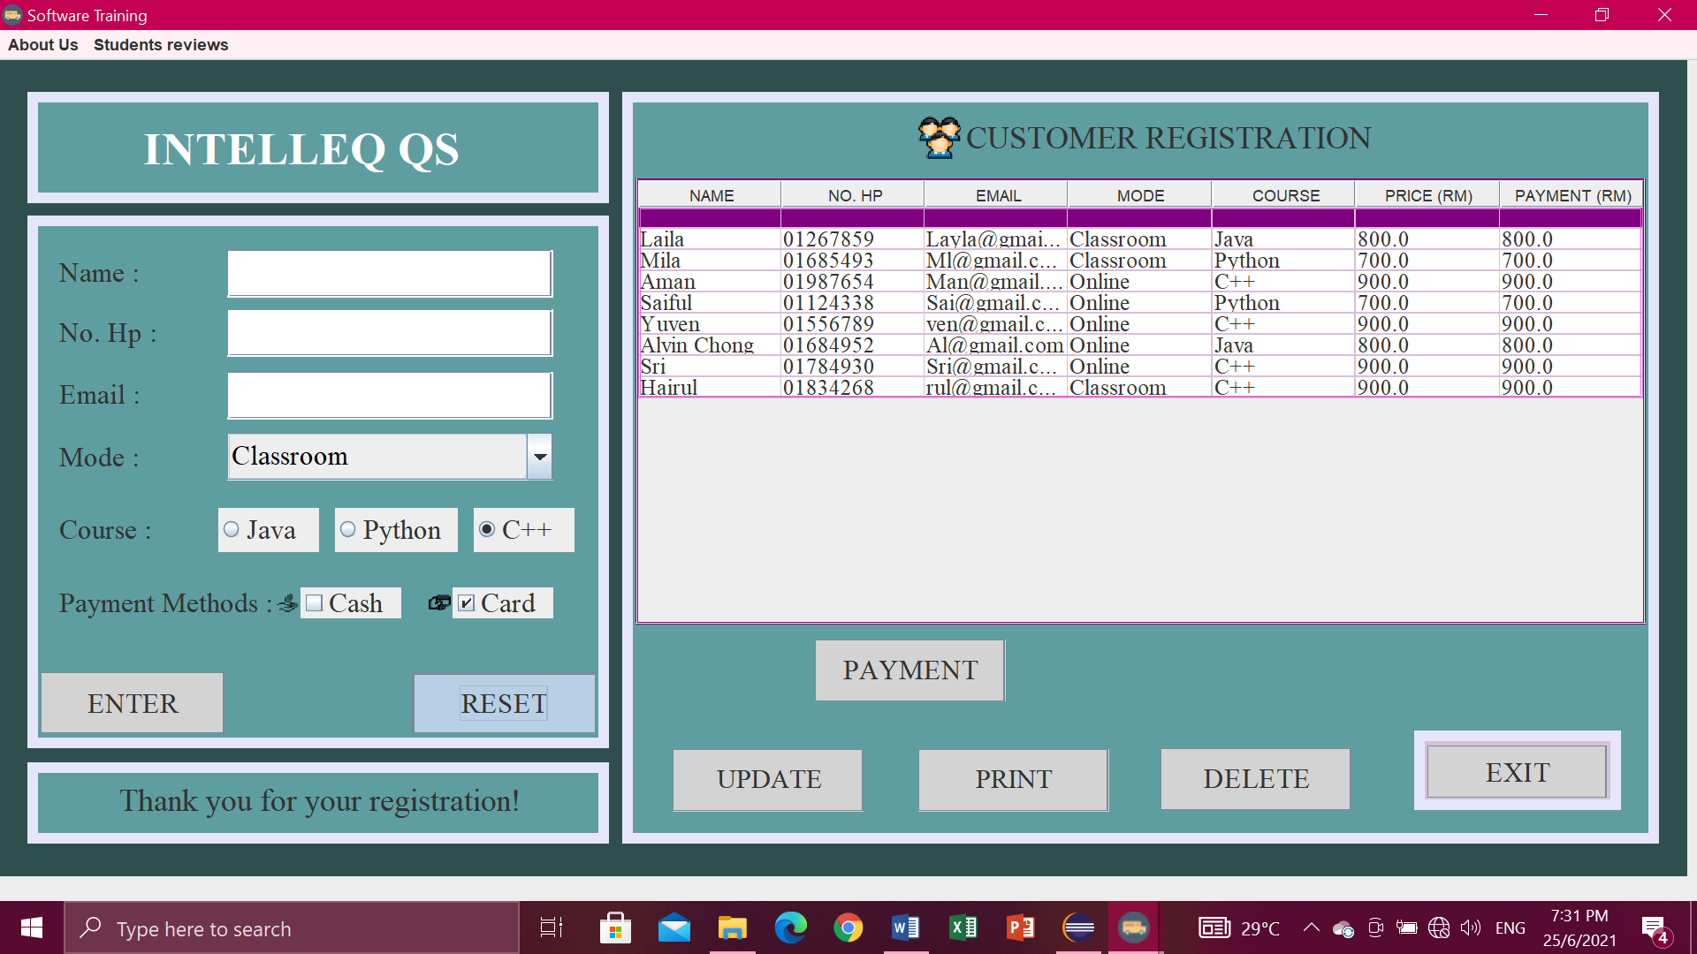

Delete button

* First you have to select row at table which one want to delete then click button DELETE, if you don’t click row to delete it will pop-up “Select a row to delete” then click OK.

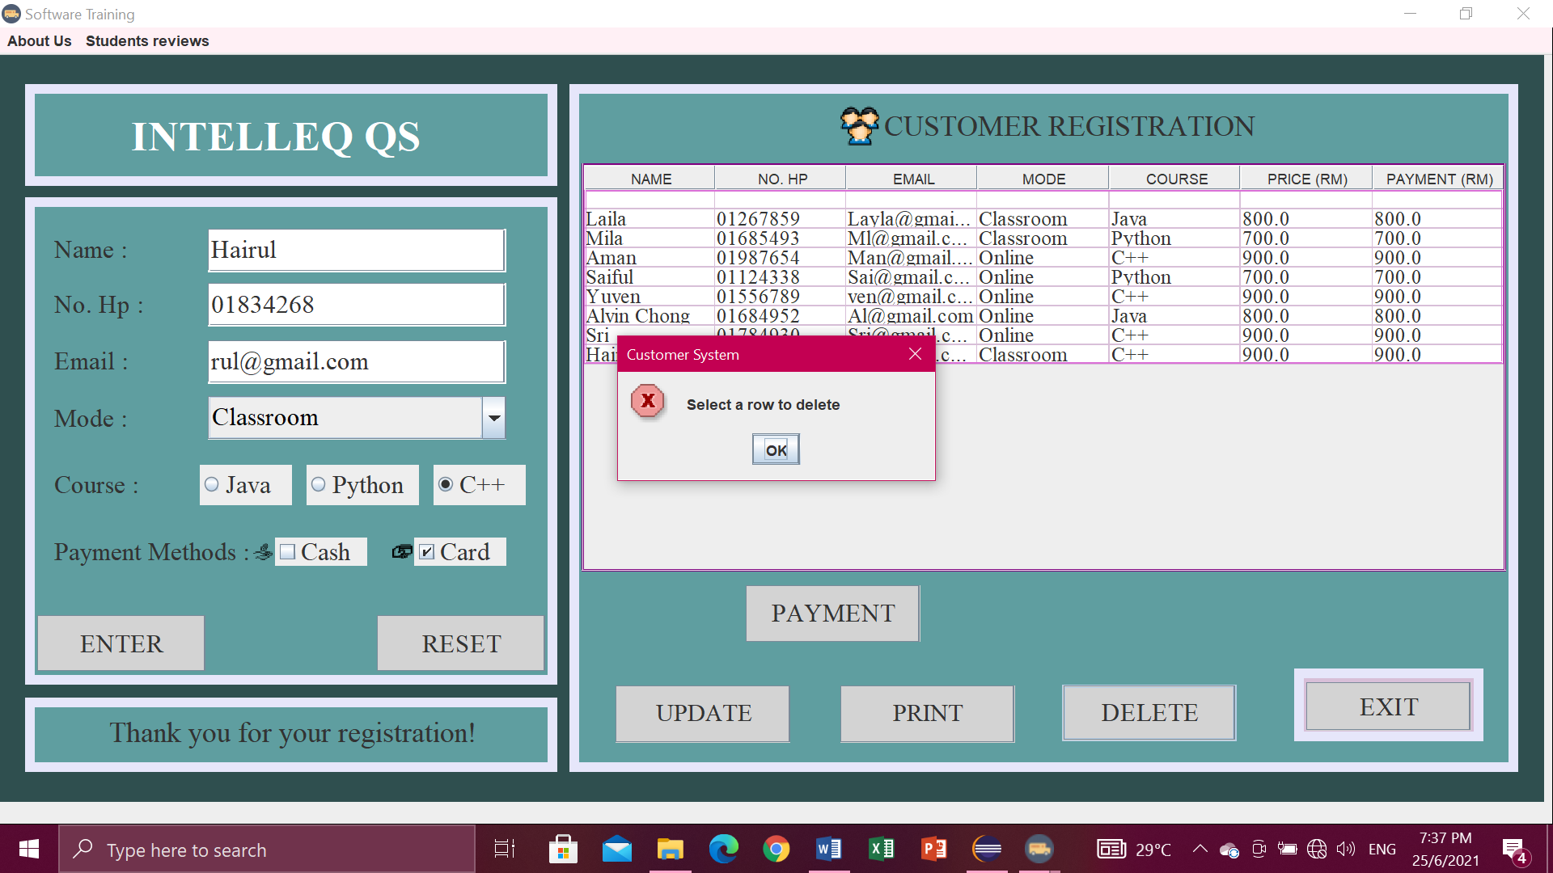

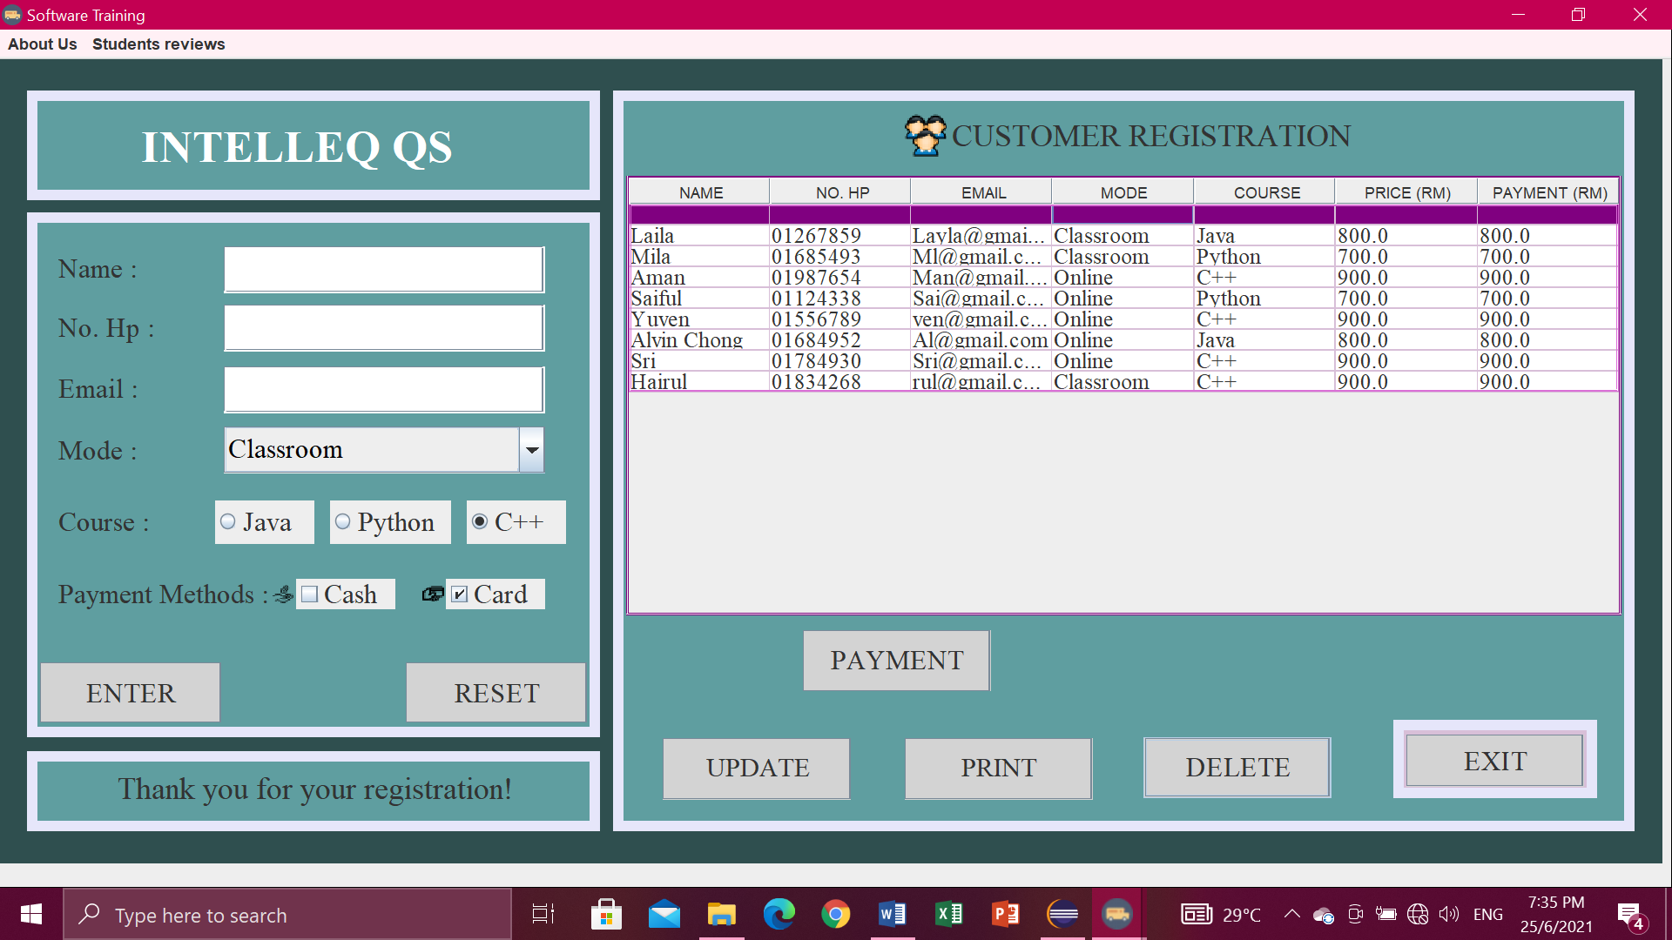

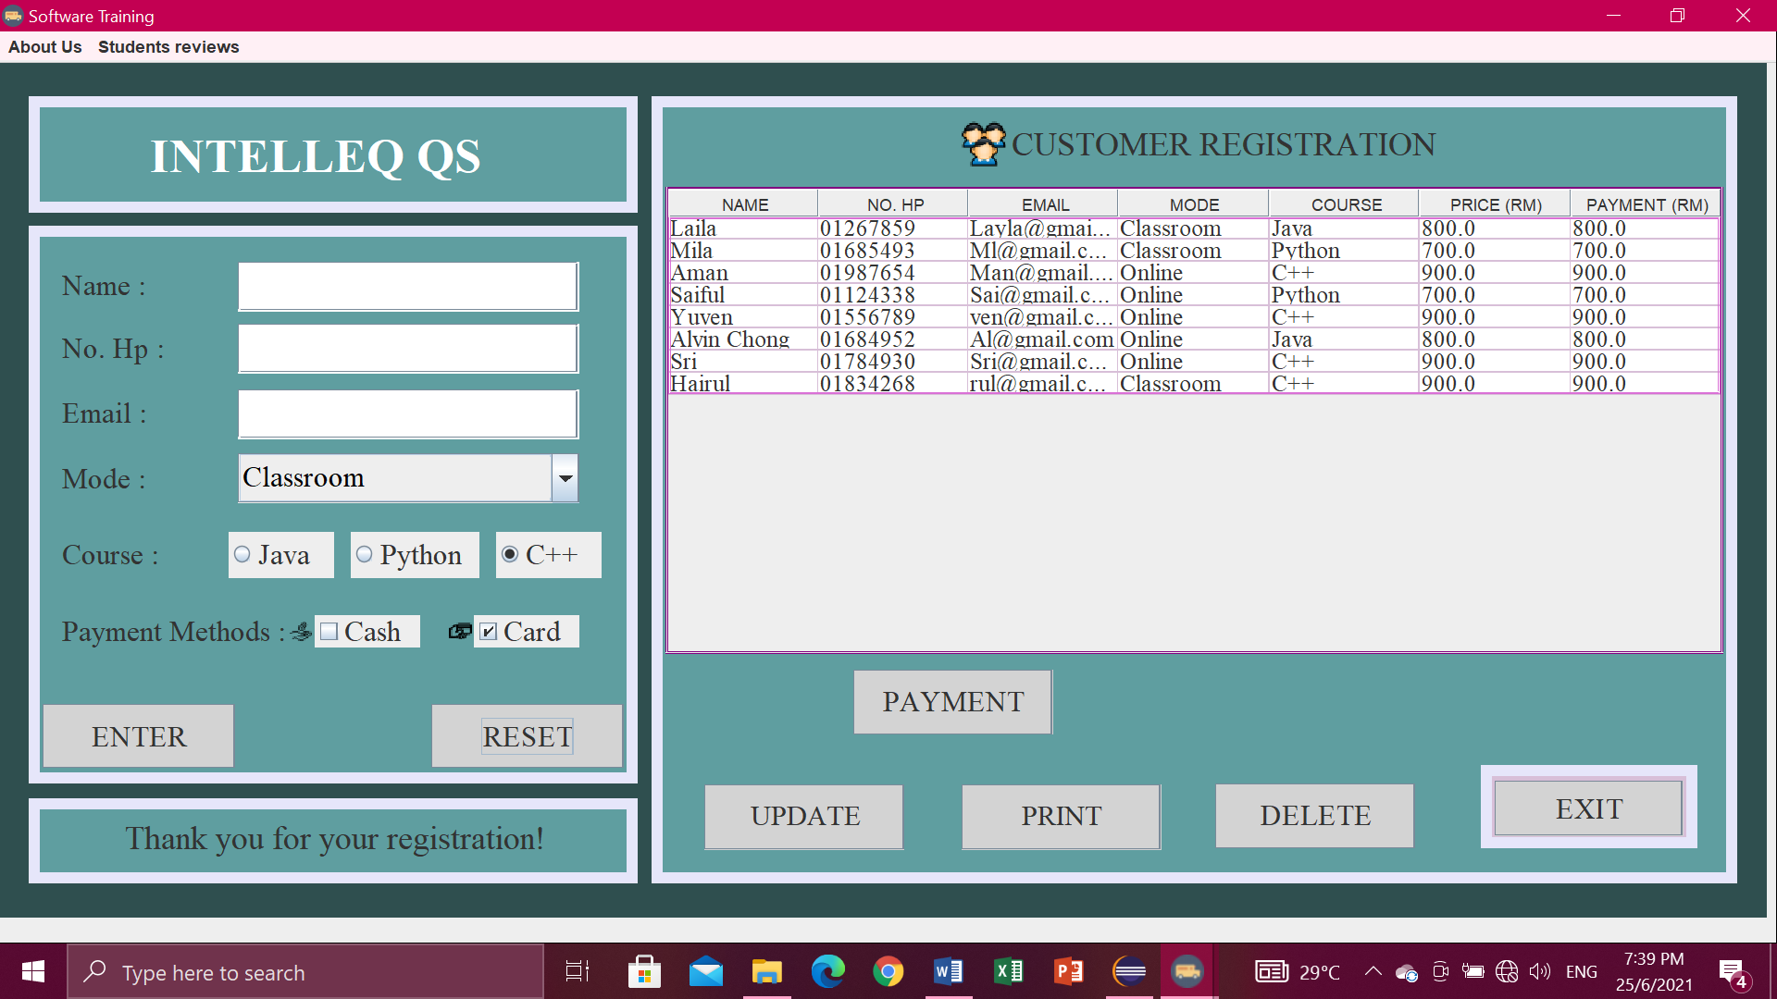

Payment button

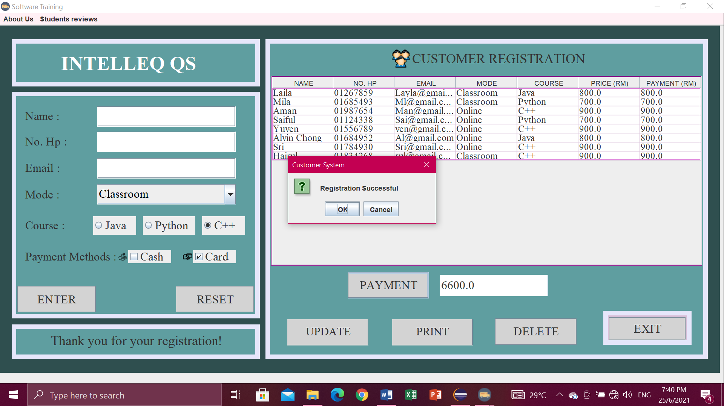

Update button

* Click button UPDATE. Then will pop-up “Data Exported”.

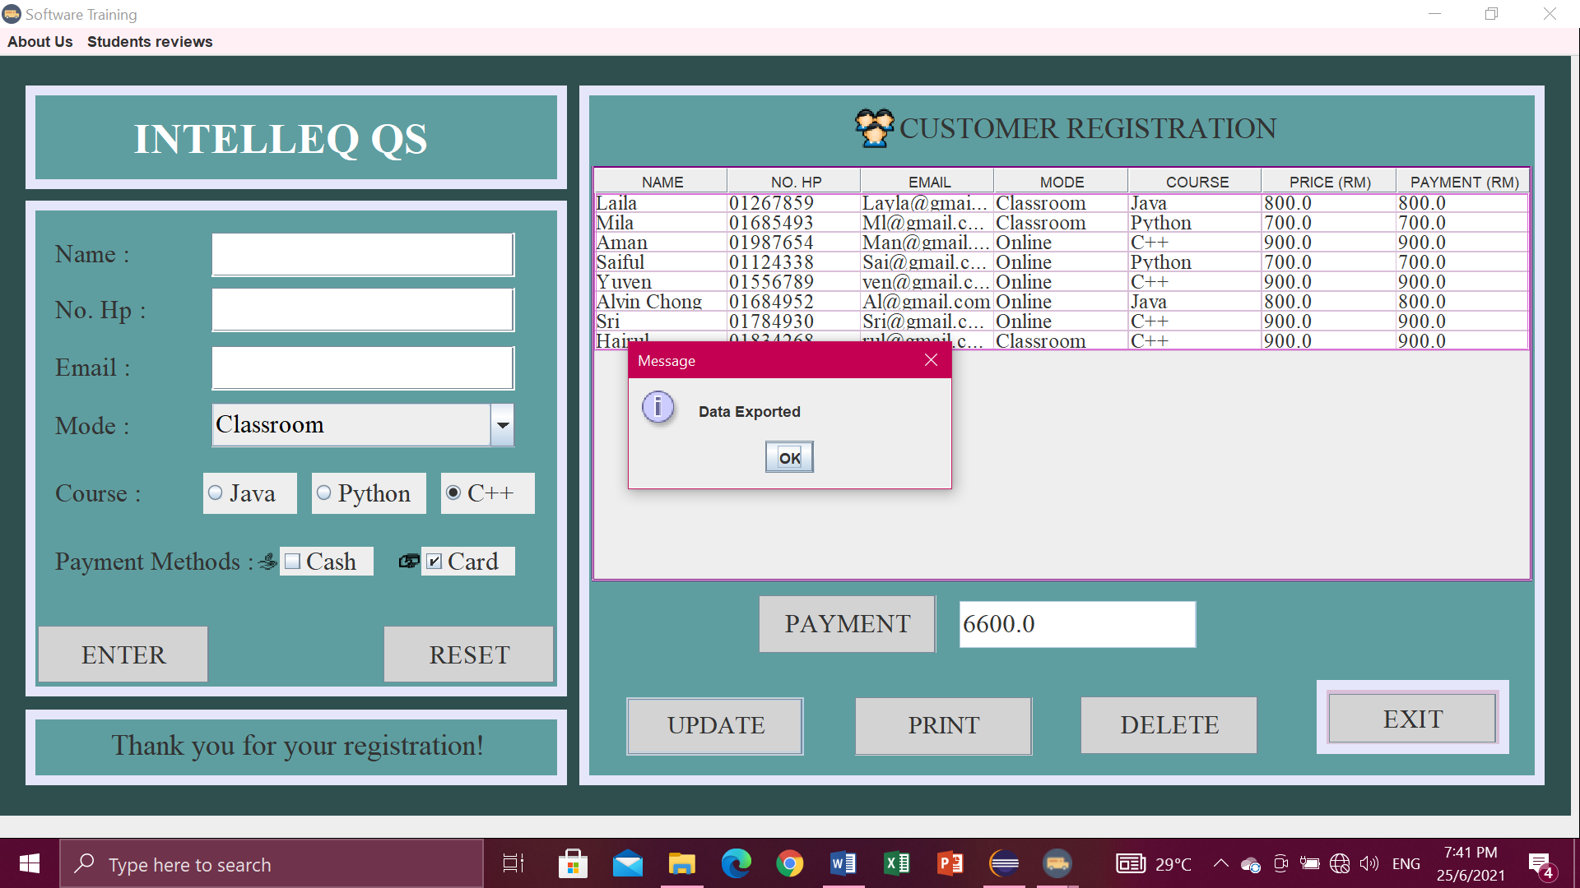

* The data exported into file io.

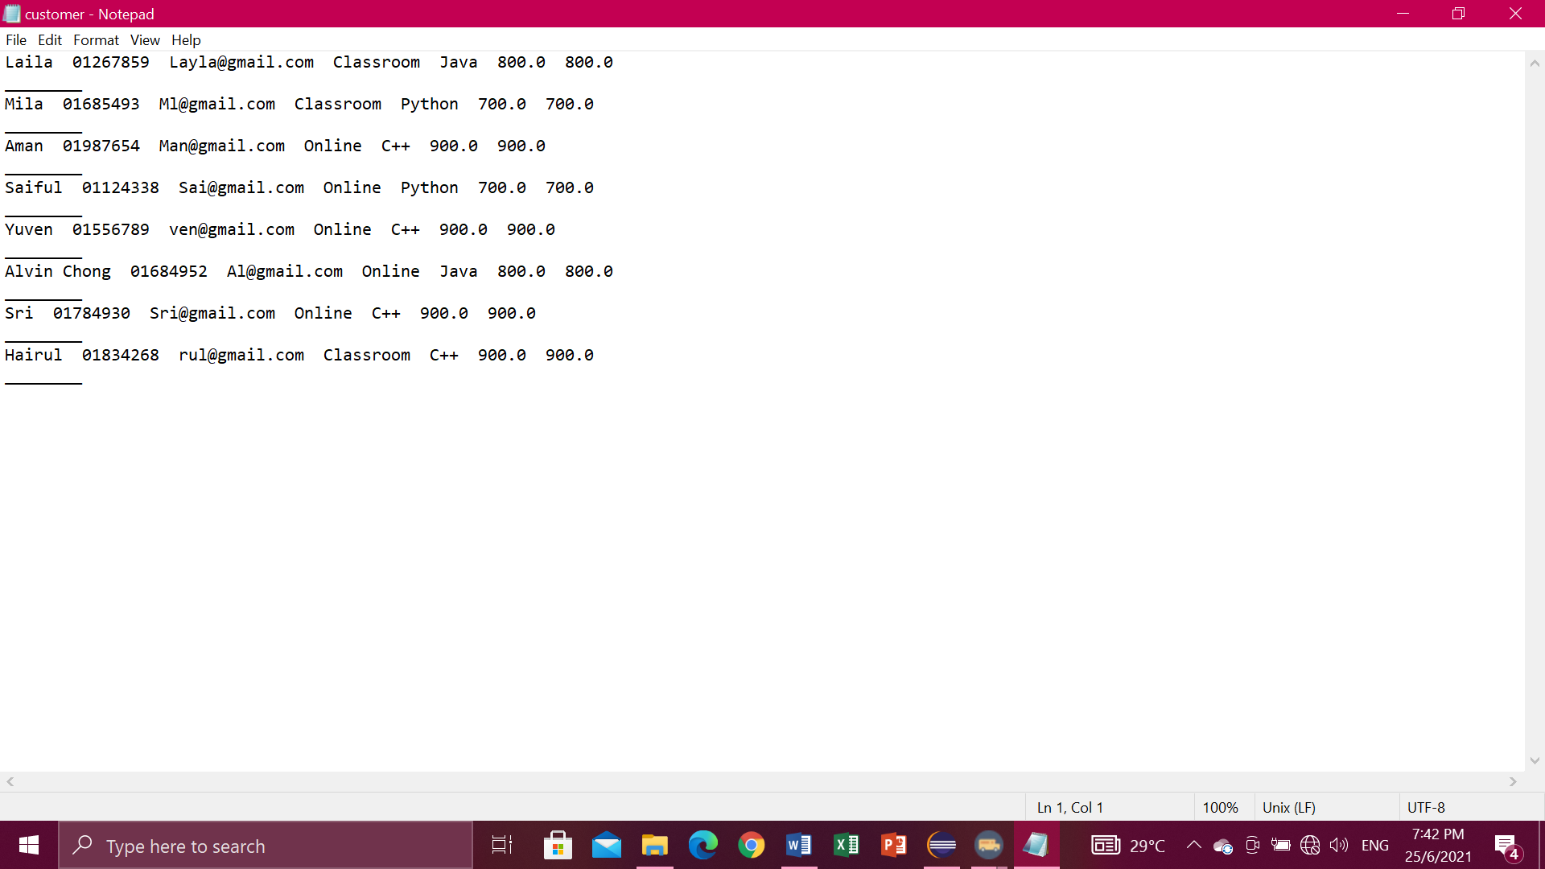

Print button

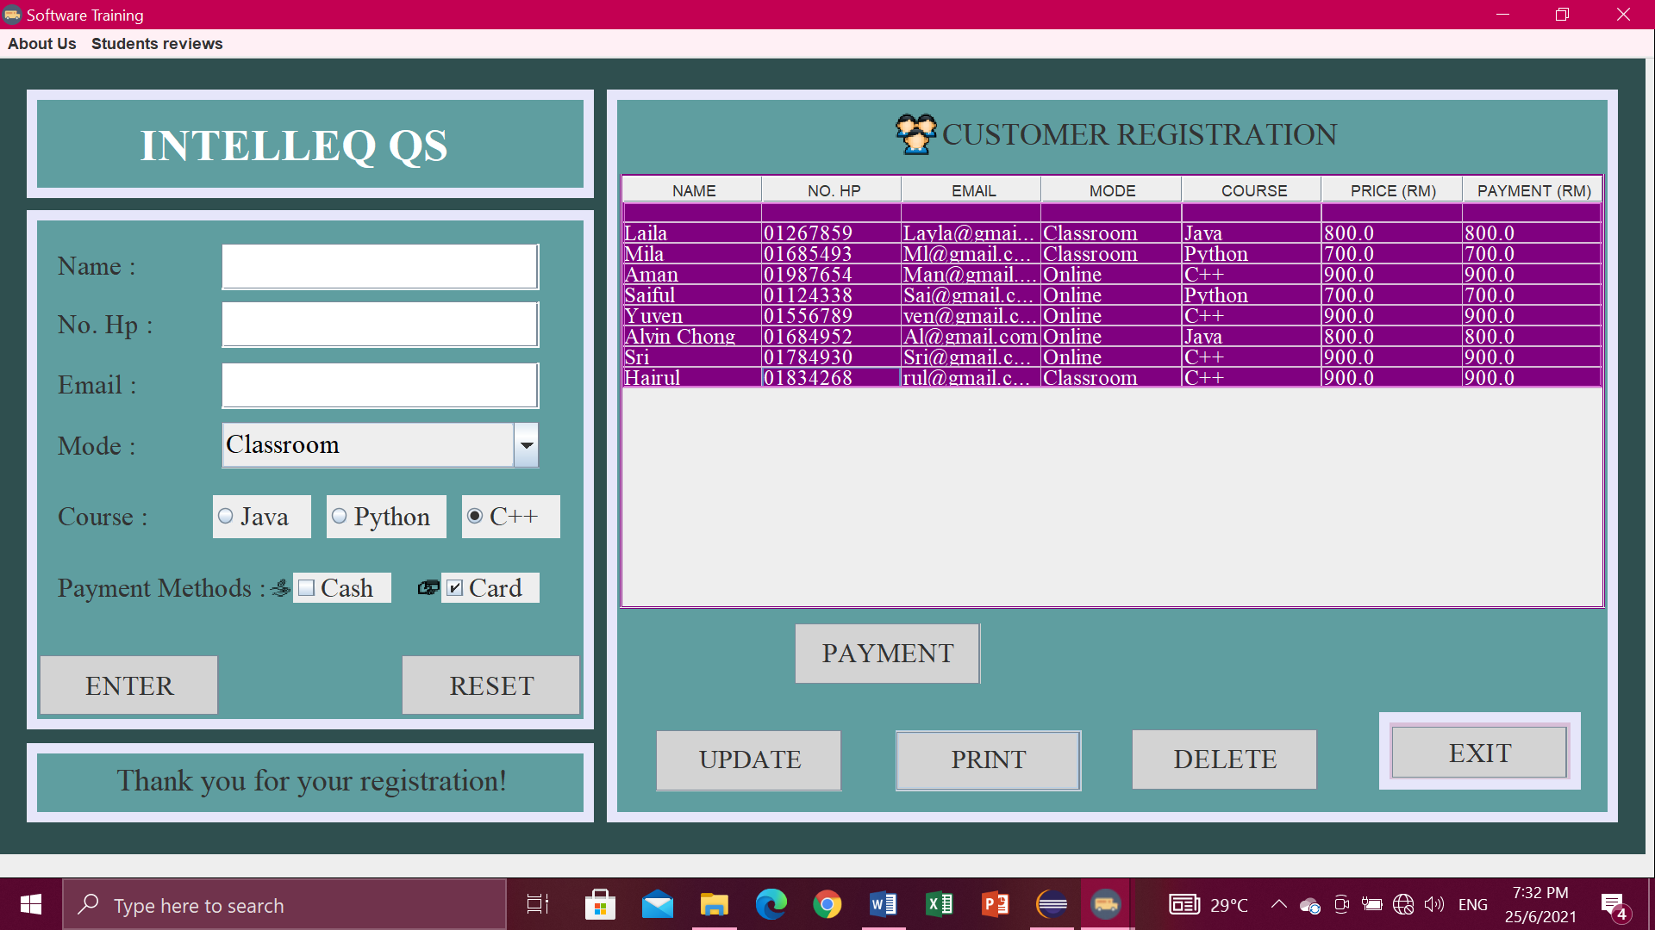

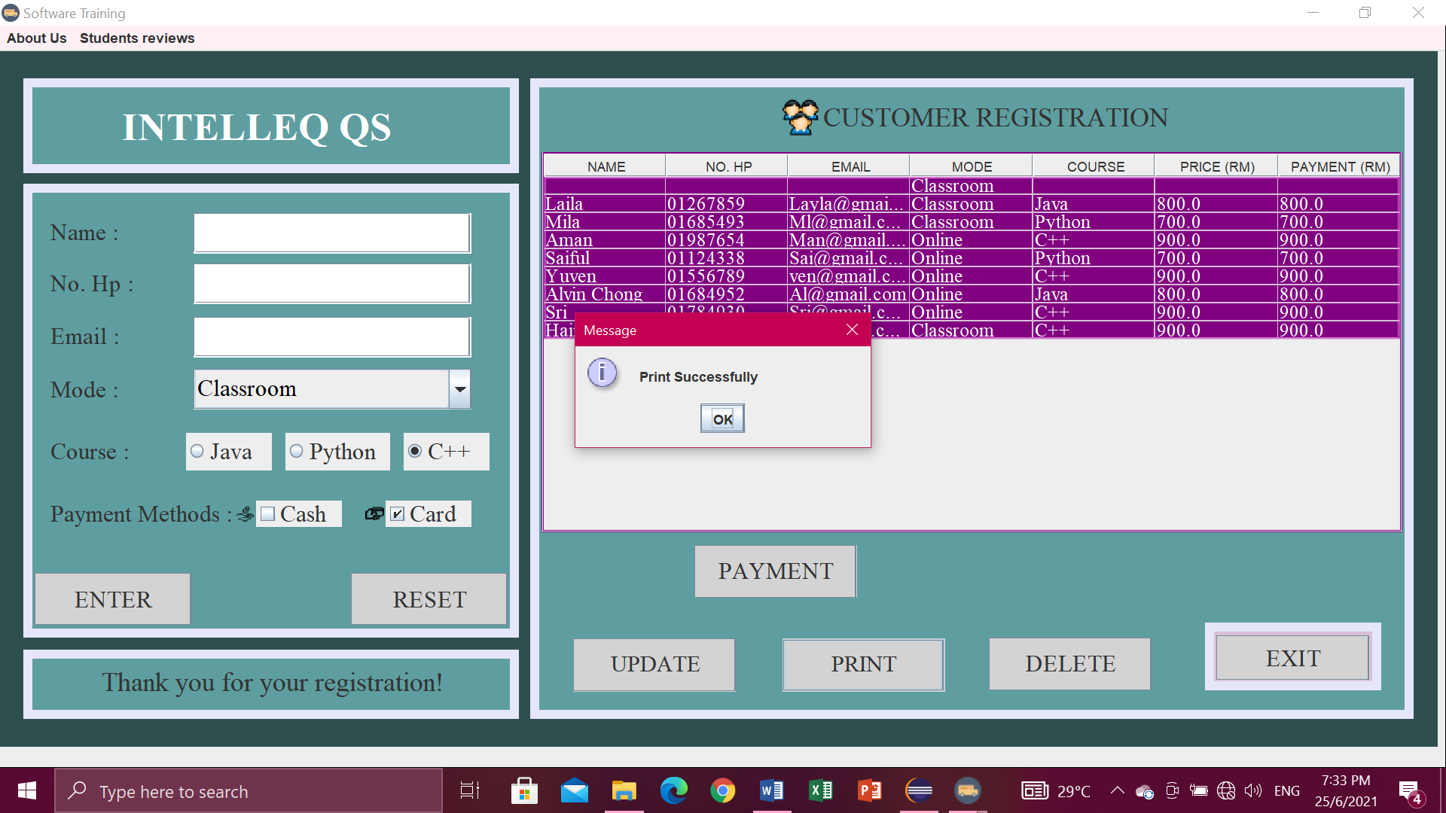

Menu bar

* For the menu bars, you can click

1. About Us , in the menu item contain Intelleq Qs,
2. Student reviews, contain Advertisement.

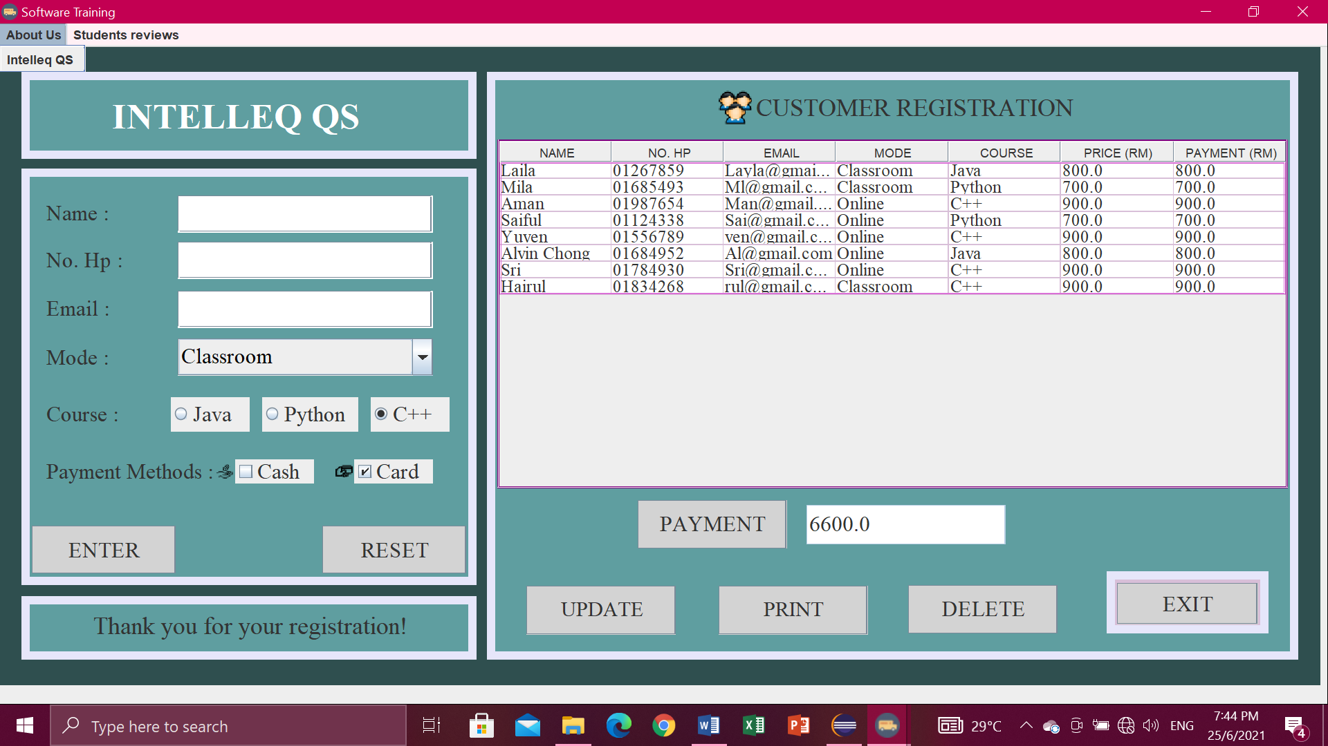

Exit button

* If you are click exit button, it will pop-up ” Confirm if you want to exit ”.Then just click Yes or No.

